**KWAME NKRUMAH UNIVERSITY OF SCIENCE AND TECHNOLOGY**

**COLLEGE OF ENGINEERING**

**DEPARTMENT OF GEOMATIC ENGINEERING**

**Spatial Analysis of Surface and Ground Water Heavy Metals in Large Scale and Artisanal Mining Areas in Ayanfuri**

A laboratory thesis report submitted for the partial fulfillment of a GIS project defense for the undergraduate studies in the Department of Geomatic Engineering, College of Engineering, Kwame Nkrumah University of Science and Technology, Kumasi.

**BY**

**Elisha Akanlo Anankansa**

(BSc Geomatic Engineering)

**JANUARY, 2021**

# DECLARATION

I hereby declare that this submission is my own work and that, to the best of my knowledge and belief, it contains no material previously published or written by another person nor material which to a substantial extent has been accepted for the award of any other degree or diploma at Kwame Nkrumah University of Science and Technology, Kumasi or any other educational institution, except where due acknowledgment is made in the Laboratory thesis.

Elisha Akanlo Anankansa **(20600448)**  …………………….. ………………….

Student Name & ID Signature Date

Certified by:

**Prof. Eric Forkuo** …………………….. ………………….

Supervisor’s Name Signature Date

Certified by:

**Rev. Dr. Emmanuel Offei Akrofi** …………………….. ………………….

Co-Supervisor’s Name Signature Date

# ABSTRACT

The legalisation of the small-scale mining sector in Ghana in 1989, gave rise to an increased activity in the area. The initial intention was to allow for small groups of persons to acquire licenses for the purposes of mining and do so in a regulated manner. Unfortunately, over the past decade persons who have had access to permits and those who are not permitted to mine have conducted their operations in a similar manner resulting in the destruction to vast expanses of land. The effect of this destruction to land has seen an increase in the prevalence of heavy metals in soils, water and the air around these mining areas. Several pieces of research have been done to try to understand how these heavy metals are released into the environment. Some of this research has highlighted the health effects as well as the impact on flora and fauna of these heavy metals. This research seeks to combine a variety of tools to help analyse the effects of some of these common heavy metals, namely Arsenic, Iron, Zinc, Lead, and Mercury in the Ayanfuri area. the research relies on satellite images from Landsat 7 and 8 to understand the spatial extent of the land degradation and also the investigate the possible trend of this activity. The research seeks to use statistical tools to see the correlation between the occurrence of these heavy metals between the period 2009 and 2019 and also establish any trends that may be found. The research analyses the spatial distribution of the occurrence of each of the heavy metals by using the gaussian regression model in kriging to interpolate possible areas around the project area that may have heavy metals present. The results showed the presence of heavy metals in unacceptable levels within the surface water in the project area. The groundwater results showed an absence of heavy metals in the groundwater, with few minor exceedances. The research established that groundwater in the project area was a good source of domestic drinking water and that surface water in the area was unsafe for use.

# ACKNOWLEDGMENT

The process leading to the finalization of this thesis has been a tough and arduous one, but through it all God was faithful and made it possible.

The guidance I got from my supervisors was immeasurable, I remain indebted to both Rev.Dr. Emmanuel Offei Akrofi and Prof. Eric Forkuo for their tireless effort to get this work to this stage after all the major setbacks. The persistence and encouragement of Prof. Eric Forkuo, in particular, cannot go unmentioned, having put together several in-person progress presentations where together with other students under his supervision at the Geospatial Lab, candid feedback was given to shape this outcome, May the Almighty Father bless you, Sir.

The final appreciation goes to my colleagues who helped to guide me through this process, may God bless you all abundantly.

# TABLE OF CONTENTS

DECLARATION ii

ABSTRACT iii

ACKNOWLEDGEMENT iii

TABLE OF CONTENTS i

LIST OF TABLES iii

LIST OF FIGURES iv

LIST OF ACRONYMS 1

CHAPTER ONE 2

INTRODUCTION 2

1.1. Background 2

1.2. Justification of the Study 5

1.3. Problem Statement 6

1.4. Aim, Research Objectives and Research Questions 7

1.5. Research Design and Methodology 8

1.6. Structure of Thesis 10

CHAPTER TWO 11

LITERATURE REVIEW 11

2.1. Introduction 11

2.2. Water Quality 12

2.2.1. Definition 12

2.2.2. Water Quality Monitoring and Assessment 12

2.2.3. Human Impact on Water Quality 13

2.3. Metals in Water 14

2.3.1. Effects of Common Heavy metals 16

2.3.2. Geology and Heavy Metals 17

2.4. Mining and Mineral Exploration 18

2.4.1. Large-Scale Mining 18

2.4.2. Artisanal and Small-scale Mining 19

2.4.3. Health Impact of Artisanal and Small-Scale Mining 20

2.4.4. Socio-Economic Impact of Mining 22

2.5. Mining and Mineral Exploration in Ghana 23

2.6. Water Quality Monitoring in Mining 24

CHAPTER THREE 26

STUDY AREA, MATERIALS AND METHODS 26

3.1. Introduction 26

3.2. Study area 26

3.2.1. Location 26

3.2.2. Geology and Soil Type 27

3.2.3. Vegetation Type 28

3.2.4. Population 28

3.2.5. Hydrology 28

3.2.6. Economy 29

3.2.7. Mining in Ayanfuri 29

3.3. Data and Materials 30

3.3.1. Water Samples 30

3.3.2. Satellite Imagery 30

3.3.3. Other Sources of Data Source 30

3.4. Methods 31

3.4.1. Water Sampling Analysis 31

3.4.2. Scan Line Correction Error (SLC) 32

3.4.3. Radiometric Corrections 33

3.4.4. Image Sub setting 33

3.4.5. Layer Stacking 34

3.4.6. Atmospheric Correction 34

3.4.7. Training Points 35

3.4.8. Georeferencing 35

3.4.9. Image Classification 36

3.4.10. Accuracy Assessment 36

3.4.11. Data Analysis 37

3.5. Limitations of Research/Data Collection 38

CHAPTER FOUR 39

RESULTS AND DISCUSSION 39

4.1. Introduction 39

4.2. Results 39

4.2.1. Trend and Spatial Distribution of Surface Water Heavy Metals 39

4.2.2. Trend and Spatial Distribution of Ground Water Heavy Metals 63

4.2.3. Surface Disturbance Map 76

4.3. Discussion 79

4.3.1. General Characteristics of Water 79

pH in Surface and Ground Water 79

Turbidity of Surface and Ground Water 80

4.3.2. Heavy Metals in Water Resources and Trend of Occurrence 81

4.3.3. Surface Disturbance 85

4.4.3.1.1 2010 Landsat Image Classification 85

4.4.3.1.2 2013 Landsat Image Classification 85

4.4.3.1.3 2016 Landsat Image Classification 86

4.4.3.1.4 2019 Landsat Image Classification 87

4.3.4. Surface Disturbance and Heavy Metals in Surface and Ground Water 87

CHAPTER FIVE 90

CONCLUSIONS AND RECOMMENDATIONS 90

5.1 Introduction 90

5.2 Conclusions 90

5.2 Recommendations 92

REFERENCES 94

# LIST OF FIGURES

Figure 1: Flow Chart of Methodology 33

Figure 2: Trend of Surface Water Arsenic (As) for 2009 -2019 41

Figure 3: Surface Water Arsenic (As) Map July 2011 43

Figure 4: Surface Water Iron (Fe) Trend 2009-2019 44

Figure 5: Surface Water Iron (Fe) Map 2010 47

Figure 6: Surface Water Iron Map (2012) 48

Figure 7: Surface Water Mercury (Hg) Trend 2009-2019 49

Figure 8: Surface Water Mercury (Hg) Map 2014 50

Figure 9: Surface Water Lead (Pb) Trend 2009-2019 52

Figure 10: Surface Water Zinc (Zn) Trend 20009-2019 53

Figure 11: Surface Water Zinc (Zn) Map 2017 53

Figure 12: Surface Water Turbidity Trend 2009-2019 57

Figure 13: Surface Water turbidity Map 2010 58

Figure 14: Surface Water pH Trend 2009-2019 60

Figure 15: Surface Water pH Map 2010 61

Figure 16: Ground Water Arsenic (As) Trend 2009-2019 64

Figure 17: Ground Water Arsenic (As) Map 2010 64

Figure 18: Ground Water Iron (Fe) Trend 2009-2019 65

Figure 19: Ground Water Iron (Fe) Map 2011 67

Figure 20: Ground Water Mercury (Hg) Trend 2009-2019 68

Figure 21: Ground Water Lead (Pb) Trend 2009-2019 68

Figure 22: Ground Water Zinc (Zn) Trend 2009-2019 69

Figure 23: Ground Water Zinc (Zn) Map 2012 71

Figure 24: Ground Water Turbidity Trend 2009-2019 72

Figure 25: Ground Water Turbidity Map 2014 74

Figure 26: Ground Water pH Trend 2009-2019 76

Figure 27: Classified images of Ayanfuri 2009,2013,2016 and 2019 78

# LIST OF TABLES

Table 1: Specific Objectives and Research Questions 8

Table 2: Pearson Correlation Matrix for Surface Water Arsenic Concentrations 42

Table 3: Pearson Correlation Matrix for Surface Water Iron Concentration 46

Table 4: Pearson Correlation Matrix for Surface Water Mercury 51

Table 5:Pearson Correlation Matrix of Surface Water Zinc Concentrations 54

Table 6: Pearson Correlation Matrix of Surface Water Turbidity 56

Table 7: Pearson Correlation Matrix of Surface Water pH 62

Table 8: Pearson Correlation Matrix of Ground Water Arsenic 63

Table 9: Pearson Correlation Matrix of Ground Water Iron 66

Table 10: Pearson Correlation Matrix of Ground Water Zinc 70

Table 11: Pearson Correlation Matrix of Ground Water Turbidity 73

Table 12: Pearson Correlation Matrix of Ground Water pH 75

# LIST OF ACRONYMS

SCP – Semi-Automatic Classification Plugin

SLC – Scan Line Corrector QGIS – Quantum Geographic Information System

ISI – Indian Standard Institution

# CHAPTER ONE

# INTRODUCTION

## Background

The problem of heavy metals in surface and groundwater resources in artisanal mining communities is well documented and its effects on the socio-economic well-being as well as the health of the people in these communities cannot be overemphasized. The minerals Commission of Ghana which has supervisory and oversight responsibility for all mining operations in Ghana has only so far been able to strictly supervise the operations of large-scale mining firms in the country and to some extent the registered small-scale mining firms in Ghana. The evidence of strict supervision of small-scale mining firms by the regulators appears half-hearted, leading to abuses of the environment, especially the water resources within some of these mining communities.

According to Norgah (2013) globally a reported 13 million people work directly in small-scale mines throughout the world, the majority in developing countries (IFC, 2012). In Ghana, over a million people engage in illegal mining, in 2010 Artisanal Small-Scale mining accounted for 23% of total gold produced (Agyarko 2014).

Small-scale mining is legal in Ghana; however, most small-scale miners are not registered with the Minerals Commission, thus making their operations illegal (Awumbilla and Tsikata, 2004). According to Mining Journal (2010), an estimated 200 mining licenses have been issued in Ghana by the Government, with 128 local companies and 51 foreign companies being the beneficiaries. Most small-scale miners don’t operate within the remits of the law because of a lack of strict enforcement, supervision, and regulations (Hilson 2006).

The biggest contributors to the pollution of water bodies as well as the environment without any form of rehabilitation being carried out after their operations; are the activities of Artisanal and Small-Scale Miners in the country. This form of mining adopts very crude mining methods and techniques, mostly involving the use of harmful chemicals in the processing of ore, for gold. The most important sources of trace elements in the environment are from mining sources (Agyarko *et al.* 2014).

All stages of mining operations depend on water. Given the importance of water for mining and the necessity of water for all life on the planet, how mining companies use and protect water sources is a critical issue (IFC 2014). Metal mining can result in acid mine drainage, cyanide and mercury contamination, and other forms of contamination (such as arsenic, iron, manganese, and heavy metals) of land and water resources (IFC 2014).

Though some metals like Fe, Cr & Zn are essential micronutrients, they can be detrimental in higher concentrations (Kar *et al*. 2008: Nair *et al*. 2010). There is therefore the need to ensure those trace elements found in the environment meet the limits acceptable by World Health Organisation (WHO) standards.

The activities of artisanal and small-scale miners; have huge impacts, especially on surface and groundwater resources. This is because of the use of water in the processing chain for the extraction of gold from the gold ore. Water is therefore essential in their daily activities on the various small-scale and artisanal mining sites. The water often comes into contact with harmful chemicals in the gold processing chain and it is sometimes improperly discharged into nearby streams, rivers, and dugouts; flowing into water extraction points that several communities may depend on for their potable water needs.

The large-scale mining firms also use water in their activities for the extraction of Gold. However, they have engineering controls (engineering tailings storage facilities) in place to ensure that the water they use, doesn’t make its way into the environment when found to contain heavy metals or harmful chemicals. There is a strict monitoring system in place to ensure that rivers, streams, underground water resources, and the environment are protected from any potentially harmful chemicals and heavy metals. Constant monitoring, sampling, and testing of the water resources are done as an additional level of assurance for the quality of water in their operational areas.

The milling, concentration of ore, and deposits of tailings and mine wastewater are contamination sources of trace elements in the environment (Adriano, 1986). Rivers, streams, and sediments are contaminated by trace elements such as Arsenic (As), Lead (Pb), Iron (Fe), Mercury (Hg), and Manganese (Mn) from artisanal mining communities/activities (Ojo & Oketayo 2006; Nartey *et al.* (2011).

In times past, artisanal mining involved only the use of unsophisticated implements such as a pickaxe, shovels, and a washing pan. This form of artisanal mining has been practiced for decades within the mining areas of Ghana. However, in the past decade, sophisticated machines such as ‘Chang Fa’ machines (small grinding machines made in China), excavators, etc, have been deployed onto large tracts of land for illegal mining (Galamsey). The activities of these heavy equipment coupled with the use of chemicals in the extraction of gold by these artisanal small-scale miners have resulted in the destruction of huge tracts of land without reclamation and without regard for its impact on surface and groundwater resources and their attendant effects on the socio-economic conditions of the people within close proximity to these illegal mining operations.

According to International Council on Mining and Metals (ICMM), artisanal mining provides a direct or indirect livelihood for over 100 million people in the developing world (IFC 2014). Justifications are being made to legalise Artisanal Small-Scale Mining (ASM) in Ghana since it is the mainstay of several communities that depend on it for their livelihoods. The impact of their operations, however, makes it impossible for any legitimacy to be given to them, to conduct their operations in the way and manner in which they have conducted them over the past years.

This project seeks to use Geographic Information Systems as a tool to analyse the results of surface and groundwater sampling carried out as part of the mining operations of a large-scale mining firm on boreholes, rivers, and streams in its catchment communities; to determine the presence or otherwise of common heavy metals; Lead (Pb), Iron (Fe), Mercury (Hg), Arsenic (As), and Zinc (Zn).These catchment communities are hotbeds for illegal mining operations by artisanal miners and some small-scale miners. This will help understand the impact of the two types of operations, which is legal large-scale and illegal artisanal/small-scale mining on the surrounding surface and groundwater resources in close proximity to these mining interests. Also, it will examine the effectiveness or otherwise of engineering controls put in place by large-scale mining firms, to manage harmful heavy metals from finding their way into the environment.

The research will propose interventions for the relevant companies, regulatory and development authorities to ameliorate the impacts of the presence or otherwise of these heavy metals in the surface and groundwater resources of these communities, which are used for a wide variety of activities including Farming, Aquaculture, potable use, etc.

## Justification of the Study

The presence of heavy metals has been found to be detrimental to the socio-economic and health well-being of persons who have regular contact with these harmful substances. The past few years have witnessed an astronomical jump in the activities of illegal miners in Ghana, which is one of the major contributors to the presence of harmful chemicals and heavy metals in surface and groundwater resources. The world is gradually facing severe weather conditions which have a direct correlation with the quality and availability of water for consumption by the general populace of every country, in the near future. There is therefore the need to investigate the patterns of these common heavy metals in water resources are, to help put in place the right mitigation strategies to forestall the negative impacts of these heavy metals on the well-being of the populace. It is equally important to understand what the trends have been all these years and to investigate potential areas of improvement as well as generate maps that may be able to predict future occurrences of these heavy metals in predominantly mining areas.

The research will also seek to draw comparisons between the incidence of common heavy metals relative to the large-scale mining areas versus that of the artisanal and small-scale mining areas as well. It is expected that it will bring into focus the type of mining that has a severe impact in respect of the presence of heavy metals, on the surface and groundwater resources in close proximity to these various mining areas and the communities and how these are being managed to minimize or eliminate its effect on the populace.

## Problem Statement

There is the perception in the minds of many persons in Ghana that large-scale mining causes irreparable damage to the environment as opposed to the impacts of Artisanal small-scale mining. Some heavy metals associated with gold like Arsenic (As), Cadmium(Cd), lead(Pb), Zinc(Zn), Copper(Cu), and Mercury (Hg) which is used to process gold ore may be released into streams deliberately or inadvertently by both legal and illegal miners (Boampomsem *et al* 2010).

On the other hand, the legal large-scale mining firms have over the years sought to improve how mining is carried out to ensure adherence to the best practices in the world, with regard to the environment, health, and safety. This is done to ensure that the environment is impacted minimally by their operations and to adopt proper disposal methods (engineered tailings storage facilities) for the discharge of potentially harmful substances within their area of operation. There is however the perception in the minds of many Ghanaians that large-scale mining also results in a significant impact on the environment.

Previous research has highlighted the presence of heavy metals in water in the mining communities of Ghana. In some instances, these have sought to relate the presence of these heavy metals to naturally occurring metals by the geology of the areas without establishing a correlation between the heavy metals and the potential type of mining that exists in those areas, which may have resulted in the presence or otherwise of these heavy metals in the surface and groundwater resources of these areas. Duker *et al*. (2018) researched the presence of arsenic, a heavy metal, in the surface and groundwater of the Bonfa area to try to explain the prevalence of Mycobacterium ulcerans in the people of the area.

Some researchers have also looked at the surface disturbance in mining communities to determine whether mining contributed to the destruction of vast areas of vegetation or not, however, they did not link that to the presence of heavy metals in the water being consumed by the people. In Tarkwa for instance, *Abaidoo et al*. (2019) conducted research using artificial neural networks to determine the extent of reclamation of land for purposes of small-scale mining and tried to explore the reclamation of disturbed areas and its effectiveness or otherwise in these mining areas.

Similarly, surface water and sediments around the Bonte area were assessed by *Agyarko et al*. (2014) to determine the presence of trace elements, which are heavy metals, and tried to relate that to the presence of artisanal and small-scale mining, as the human influence in contributing to the presence of these trace elements. The results showed a correlation between illegal artisanal and small-scale mining with the presence of certain trace elements in surface water and sediments.

It is generally known that both large-scale mining and small-scale mining activities produces a trace of elements in surface and underground water. However, the presence or otherwise of heavy metals in surface and groundwater resources and its possible relationship with mining activities in the Ayamfuri area and its potential impact on the communities has not been fully investigated.

## Aim, Research Objectives and Research Questions

This study aims to assess if there is a correlation between the presence or absence of heavy metals in surface and underground water and ming activities (large-scale and small-scale mining). It seeks to develop spatial decision-making maps of heavy metals in surface and groundwater within the Ayanfuri area, to be used as a preventive system to help put in place the requisite mitigation measures, to reduce the impact of these harmful metals on the socio-economic and health well-being of people in these communities. To achieve the aim set out in this study and to arrive at the conclusion, the objectives and research questions in Table 1 has been formulated.

Table 1: Specific Objectives and Research Questions

|  |  |  |
| --- | --- | --- |
|  | Specific Objective | Research Question |
| 1 | To analyse the presence or absence of heavy metals in the water resources around Ayanfuri and the trend of occurrence. | How can heavy metals in water resources be spatially analysed in mining communities and their trends displayed? |
| 2 | To investigate the areas in the communities, with or without heavy metals in the water resources. | Which parts of the catchment communities have heavy metals present in their surface and groundwater sources? |
| 3 | To determine whether mining activities contribute to the presence of heavy metals in water resources. | How does surface disturbance for purposes of mining contribute to the presence of heavy metals? |

## Research Design and Methodology

The study employed systematic analysis of water quality and geospatial analysis to investigate the relationship between large-scale and small-scale mining activities and the presence of heavy metals in the Ayamfuri area. The study is divided into 6 stages. It involves the background information of the study, review of literatures related to the study as well as the methodology used for the study. The various stages of this study are segmented into chapters and are achieved in 6 steps as seen in Figure 1.

Chapter 1

Step1: Define the Problem

Step 2: Literature review

Chapter 2

Objectives 1

Step 3: Data collection and

Methodology

Chapter 3

Objective 2

Step 4: Analysis and Presentation of results

Objectives 3

Chapter 4

Step 5: Discussion of results

Step 6: Summary, Conclusion and Recommendation of the study.

Chapter 5

Figure 1: Research framework and methodology

The first stage of this study explains the background of the study. At this stage, the problem this research work seeks to address is properly explained and defined. It also includes the research aims and objectives as well as research questions of the study. The second stage constitutes analysis of various literatures related to the research work. This stage highlights the various literatures on concepts of water quality, especially the impacts of heavy metals. The socio-economic impact of mining is also highlighted. Stage 2 also contributes to answering of the first objective which seek to determine the presence or absence of heavy metals in the water resources around Ayanfuri and the trend of occurrence.

Stage 3 entails the data collection and methodology. The aim of this empirical study is to investigate the presence of heavy metals in samples of water. Water quality analysis will be performed and image processing and analysis conducted to establish surface disturbances. In State 4, the results obtained are presented and discussed. Drawing from the data collected in Step 3, and the analysis in Step 4, objectives 1 and objective 2 are achieved. In Step 5, the results presented in step will be discussed to established whether or not there is a correlation between the presence of heavy metals and mining activities. This seeks to address the third objectives of this study.

Based on the steps previously undertaken, a conclusive discussion, summary and recommendations are then made on the study indicating the objectives achieved and how the research questions have been answered, these were done in Step 6.

## Structure of Thesis

The thesis is divided into five (5) chapters. The first chapter will give a general introduction to heavy metals and harmful chemicals caused by mining activities and how GIS has been used to showcase potential challenges and proffer solutions to curb its impact. It will comprise the background, the problem statement, the objectives, the research questions, the justification, and the scope of the study.

Chapter two reviews the relevant literature regarding surface and groundwater heavy metals and chemicals caused by artisanal and large-scale mining and the applications of GIS in determining the impact.

Chapter three gives a description of the study area and the research methodology that will be used in the acquisition of data and the spatial analysis that will be carried out.

Chapter four presents the results of the empirical study and discuss the results against literature. The chapter discusses the spatial distribution of the heavy metals and surface disturbances.

Chapter 5 presents the conclusions drawn from the study in order to answer the main research question and makes recommendations for future studies and policy direction.

# CHAPTER TWO

# LITERATURE REVIEW

## Introduction

The chapter provides a review of theoretical framework and literature as a basis of carrying out this research. It first discusses water quality as a concept and the impact on water quality. It further discusses metals in water and the effect of common heavy metals. It further discusses geology and its impact on ground water. The chapter further previews literature on mining and mineral exploration with emphasis of large scale and artisanal mining, it also presents the health and socio-economic impact of artisanal and small-scale mining.

## Water Quality

### Definition

The quality of water refers to the water’s characteristics for the purposes for which it is used such as drinking. The general characteristics of water involve the physical state of the water determined by the Turbidity, Total Suspended Solids (TSS), Total Dissolved Solids (TDS) and the general appearance; The chemical characteristics include the PH, Potassium, Chlorine, Sodium, Calcium, Magnesium, Sulphate(SO4), Nitrate(NO3), Nitrogen Dioxide(NO2) etc.; The heavy metals characteristics include Iron(Fe), Arsenic(As), Lead (Pb), Copper(Cu), Zinc(Zn), Mercury(Hg), Manganese(Mn), Chromium(Cr), Nickel(Ni) Aluminium (Al) and Biological characteristics. The levels of all these physical, chemical, biological, and heavy metals in the water being assessed determine the quality of the water and whether it can be used for human consumption or even some industrial purposes. Some heavy metals associated with gold ore may be freed to enter streams and groundwater during processing for gold (Boamponsem et. Tal., 2010).

### Water Quality Monitoring and Assessment

Water quality monitoring is carried out to ensure that the characteristics of water are known at any given point in time. The monitoring involves the use of special apparatuses to collect water samples on a daily, weekly, monthly, quarterly, or yearly basis and analysing the samples collected in the laboratory to determine the physical, chemical, biological and heavy metals state of that collected sample.

In the mining industry, this information is critical to the continuous operation of large-scale companies. The data collected is submitted to the Minerals Commission, Environmental Protection Agency, and the Water Resources Commission on a regular basis. Independent assessments are equally carried out within the various large-scale mines to corroborate the findings of the companies, this is mostly done by the regulators, Minerals Commission, and Environmental Protection Agency.

The management of mine waste in tailings dams is critical to prevent the release of heavy metals contained in the tailings from entering the environment (Bempah et al., 2013). The regular monitoring and testing of the water quality ensures that any accidental or deliberate release of heavy metals into the environment can be mitigated. The results collected are compared with the known WHO standards and in some instances local Standards Authority standards for those characteristics being measured.

### Human Impact on Water Quality

The water quality in many areas where artisanal small-scale mining is prevalent is usually very poor. The color of the water and its turbid nature in appearance alone is sufficient to indicate that the water quality will not meet any desirable standards in the world. The Ghana Water company over the past few years has had cause to highlight the difficulties, first of all at their various intake points to extract enough raw water for production and also the cost of processing and making water safe for consumption to the general populace. This is a result of the human activities upstream of their water treatment plants. Primarily, the sources of these production difficulties are the impacts of farmers close to rivers and streams, activities of sand winning in the river basins, and predominantly illegal mining activities. There are significant costs to the populace because of these illicit activities since the cost of treatment of water for instance is transferred to the final consumer who may not have played any direct role in the pollution of these water sources. Surface water pollution is worrisome because of the dependence of rural small-town communities on the rivers and streams for their potable water needs (Atua *et al.* 2014: Gyan-Boakye *et al.* 2008).

Over the past century, gold mining in particular has been an essential component of Ghana’s Gross Domestic Product (GDP). However, in recent times these mining activities appear unpopular in the various host communities. It is regarded as a potentially significant source of Hg, Pb, and other heavy metals contamination of the aquatic environment, due to activities such as mineral exploitation, ore transportation, smelting and refining, and disposal of tailings and wastewater around mining areas (Armah *et al.* 2010).

There are grave concerns about water degradation due to the prevalence of illegal artisanal and small-scale mining, besides land degradation, loss of biodiversity and other natural resources, and deforestation (Donkor *et al*. 2006). These have the potential to gravely affect our economic potential as a nation going into the future.

According to Amegbey and Eshun (2003), the main environmental challenges associated with artisanal gold mining activities in Ghana are mercury pollution from the processing of gold, resulting in the destruction of the ecosystem and degradation of the environment. The devastation has grown to levels where civil society and other interest groups are calling for a state of emergency to be declared to properly deal with the catastrophe caused by illegal mining to the environment, water bodies, and health of the people.

## Metals in Water

Heavy metals are elements in the environment that have the potential to exist for a very long time without degrading and potentially causing a significant impact on the environment. Heavy metals have been found to be detrimental to the human body when it comes into contact with the body or is ingested over a period (Marschner 1995). This is a result of the body’s inability to process these heavy metals in high concentrations.

Some heavy metals are essential micronutrients in the environment that are essential for plant and animal growth (Marschner 1995). These micronutrients like Copper (Cu), Iron (Fe), Manganese (Mn), Nickel (Ni), and Zinc (Zn) are critical for the process of life, they are non-degradable in the environment and therefore can be found in sediments and transported using surface and groundwater to potential water extraction points. Many other metals like Cadmium (Cd), Chromium (Cr), and Lead (Pb) have no known physiological activity, they are very detrimental beyond a certain threshold in the environment (Marschner 1995). These thresholds are very narrow for some of these elements like Pb (0.10 mg/L) (ISI, 1982), and Cu (0.050 mg/, L) (Rizwan et al. 2021).

The predominant sources of trace metals in the environment are mining sources. In Ghana, there exists large-scale mining, which is highly regulated, small-scale mining which is somehow regulated; though the evidence of a strict regulation regime as observed in the case of large-scale mining appears absent and, artisanal small-scale mining (galamsey) is not regulated in any way. It is estimated that over 200 legal mining licenses were issued in 2009, to mining firms in Ghana by the Minerals Commission to mine Metals like Gold, Manganese, Bauxite, diamonds, etc. There were 51 licenses to foreign companies and 128 to local companies (Mining Journal 2010).

It is also estimated that approximately 100,000 people are involved in small-scale mining (Minerals Commission, 2010). Approximately 60% of the 100,000 estimated to be involved in small-scale mining are doing so illegally (Obiri *et al.* 2006). Small-scale mining in Ghana is legal, however, because most of these miners are not registered and thus unregulated by the minerals commission of Ghana, their activities are illegal in nature.

The unregulated artisanal and small-scale mining regime in the country has a direct relationship with the presence of certain heavy metals in most of the mining communities in the country, especially areas rife with the presence of illegal mining. The waste produced by the method of extraction and disposal in the processing for gold by artisanal small-scale miners has serious effects on the environment and the livelihoods of persons in most artisanal mining communities in Ghana (Ontoyin 2014, Agyeman 2010: Obiri *et al*. 2006).

Anthropogenic activities like mining, ultimate disposal of treated and untreated waste effluents containing toxic metals chelates Amman, *et al.* (2002) from various industries such as steel plants, tanneries, thermal power plants and the indiscriminate use of fertilizers, pesticides which may contain heavy metals may affect water quality. This may result in serious environmental problems which may be a threat to human beings (Lantzy and Mackenzie (1979); (Nriagu, 1979); (Ross 1994) and sustaining aquatic biodiversity (Ghosh and Vass 1997; Das *et al*. 1997).

Among the inorganic contaminants of river water, heavy metals are gaining prominence because of their inability to degrade and often accumulate to high levels, resulting in a lethal biological effect (Kar, D *et al*. 2008: Jain, 1978). In Ghana, both Mercury (Hg) and Arsenic (As) have been associated with surface water contamination in artisanal gold mining areas (Armah *et al*., 2010).

### Effects of Common Heavy metals

The common heavy metals found in mining areas, which may come into direct contact with persons exposed to mining and those who indirectly come into contact through environmental relationships, such as farming, aquaculture, domestic water consumption, etc. result in various health implications for the affected persons.

In the Amansie West district of the Ashanti Region, Duker *et al* (2004) determined that there was a higher susceptibility to Buruli Ulcer for persons within the artisanal small-scale mining areas due to both direct and indirect exposure to Arsenic enriched soils and water. This, they found resulted in the weakening of the immune system of these people and thus resulting in them easily contracting the disease since their bodies could not fight it off.

It has been widely established that persons who come into contact with mercury fumes for instance are also at very great risk of certain terminal diseases (Khan et al., 2005; Esdale and Chalker, 2018). The artisanal and small-scale miners within some of these highly impacted illegal mining communities have shown cancers and other disease that are terminal in nature over the past few years as a result of their exposure to toxic chemicals, especially mercury poisoning (Haile et al. 2017).

Aquatic life, which is exposed to some of these dangerous chemicals is equally wiped out in their numbers in some of these areas (Kwansa-Ansah et al. 2017). Sodium Cyanide for instance can leak into the environment if the containment facilities such as engineered tailings storage facilities are found to be deficient in sealing it off from the environment. The impact is catastrophic. This is however not heavy metal but a chemical that is used in the gold extraction process.

The presence of heavy metals in potable water, for instance, deprives those dependent on it for their livelihoods of safe and healthy drinking water. Though they may consume this heavy metal-laden water without knowing the consequences, in the long term, it will manifest in all sorts of diseases/illnesses in them. According to the Commission on Human Rights and Administrative Justice CHRAJ (2008), artisanal small-scale mining apart from its destruction to vast portions of the environment also violates the basic human rights of persons who reside within communities near these artisanal and small-scale mining interests. The presence of illegal mining results in the violation of the human rights of the impacted communities, since it denies the people access to clean potable water and good health. (CHRAJ 2006; Kumah, 2006)

### Geology and Heavy Metals

The geology of an area has a huge influence on the occurrence of certain heavy metals in the environment. Cadmium for instance is usually present in rocks and soils. It occurs naturally in zinc (Zn), lead (Pb), and Copper (Cu) ores, in coal and other fossil fuels and shale (Weiner E.R. 2000). These deposits which are naturally occurring can serve as natural sources of surface water, especially when they are in contact with soft acidic waters.

Other research has shown that metals such as Arsenic found in mining areas is as a result of mining activities exposing the Arsenic which may be buried deep in the ground and thus causing it to come into contact with environmental agents such as water and soil and thus making direct contact with humans who depend on it for their livelihoods. *Duker et al.* (2018) established that arsenic was a naturally occurring heavy metal in the Bonsa area of the Ashanti Region. This coupled with the prevalence of illegal artisanal small-scale mining in the area becomes a lethal combination resulting in the prevalence of the Buruli ulcer disease among the populace.

Amponsah et al. (2015) found that the rainwater collected in Ayanfuri contained an average of 0.51mg/l of iron, in excess of the WHO limit of 0.03mg/l.

The geology of an area plays a significant role in the presence or absence of certain heavy metals in the groundwater and the surface water of these areas.

## Mining and Mineral Exploration

### Large-Scale Mining

Large Scale Mining is a Mining Method involving the use of sophisticated equipment to bring out mineral-containing ore from deep within the earth to be processed into various precious metals, using large processing plant assemblies, and disposing of the waste material in an environmentally controlled manner. In Ghana, large-scale mining commenced in the colonial era, thus making Ghana one of the world’s biggest producers of precious Minerals such as Gold, Diamond, Manganese, and Bauxite. The Ashanti and the Western Regions of Ghana are the major mining areas (Bempah et al., 2013). The mining for Gold for instance produces minor metals after processing such as Silver which may also be in commercial quantities.

The most common type of large-scale mining in Ghana is surface or open-cast mining which involves opening a pit from the surface of the earth and bringing out the precious minerals onto the surface by the use of haulage dump trucks. This type of mining treats all material types Oxides (Soil/Sand), Transition Materials (Sedimentary Material), and Fresh Materials (Rock). The Underground Mining method which was once the dominant mining method used in Ghana, has now become the less dominant form of mining. The operational costs for the underground method of mining makes it uneconomical unless the deposit is huge and the prevailing gold price is good.

The Minerals Commission of Ghana (MINCOM) and the Environmental Protection Agency (EPA) heavily regulate this area of mining. This is because of the sensitive nature of the chemicals and processes involved in mining. This is because if the chemicals such as Cyanide used, if not well controlled, can lead to major environmental catastrophes. The release of Cyanide and it’s associated heavy metals from mining tailings storage facilities for instance can be either deliberate or accidental (Boamponsem et al., (2010). The regulators thus ensure that the mining companies operate by the agreed conditions of their permits without fail. Where breaches occur, there are stringent repercussions for the offending company which in some cases can lead to a closedown of the mine.

The land area for large-scale mines varies with most of them exceeding one hundred acres at a minimum. The Minerals Commission will normally approve large-scale mining blocks of up to three hundred blocks per lease. The area of a mining block is approximately 0.21 Km2. therefore, the maximum lease size is approximately 63 km2. Large-scale mining leases and mining permits have tenure and are renewable at expiration.

### Artisanal and Small-scale Mining

Small Scale Mining is a method of mining where small equipment and machinery are used in the mining and processing of gold. The equipment usually are small excavators, water pumping machines, and Washing boards and carpets for trapping free gold. This type of mining usually happens within the Oxide and Transition materials. This method usually avoids Fresh (rock) materials due to the depths at which they are found and the cost of explosives and treatment or processing. Most small-scale mining usually, therefore, happens within the alluvial deposits where it is easy for them to have a source of water for treatment. The degradation of the environment due to mining in Ghana is due to the reckless use and disposal of chemicals in open pit and alluvial mining processes especially (Bempah et al., 2013), the small scale and artisanal area account for this in large part.

Small-scale mining is also regulated by the Minerals Commission and the Environmental Protection Agency; however, they are not as strict with them as they are with large-scale mining companies. This, therefore, leaves them to sometimes breach the rules and employ methods frowned upon by the regulators. This attitude of small-scale miners not playing to the rules resulted in a ban on all forms of small-scale mining in the year 2017 in Ghana and a process subsequently put in place to have them register afresh and have Global Position System (GPS) trackers installed on their equipment, this has not been too successful and the uncontrolled destruction by the small scale miners continue in some instances.

Small-scale mining leases are usually limited to an area of 25 acres by the Minerals Commission per concession.

Artisanal Mining is a rudimentary method of mining where traditionally, artisanal miners employ small tools in the mining and processing of gold, usually with the use of equipment such as Pick Axes, Shovels, Washing pans, etc. they rely heavily on the use of water in the processing for gold, hence also occurs mostly within the alluvial deposits. This method however has seen a transformation since the introduction of the Chinese-made ‘Chang Fa’ machines, these equipment allow the artisanal miners to process much more ore and thus result in damage to vast areas especially along rivers and streams as water is used heavily for the processing of gold using this method. This type of mining accounts for approximately 10% of mineral revenue in Ghana (Armah, *et al*. 2010). The lucrative nature makes it an easy source of revenue for persons in the communities where mining exists, despite the danger associated with that method, both to the environment and the individuals.

### Health Impact of Artisanal and Small-Scale Mining

The health implications of water quality are varied and diverse in nature. There are immediate health challenges and there are long-term challenges to health. The immediate challenges to poor water quality will manifest immediately after ingesting unwholesome water in the form of diarrhea and vomiting and stomach pain. However, there are other implications such as long-term illnesses in the form of cancers and organ failures that may not be immediately noticeable.

According to Agyeman (2010) the common health conditions in artisanal small-scale mining areas are Malaria prevalence because of open pits filled with water, respiratory tract infections due to the inhalation of dust and fumes, tuberculosis, skin disease, and miscarriages.

There are deadly diseases associated with these heavy metals in the environment, such as edema of the eyelids, tumors, congestion of nasal mucus membranes and Pharynx, stuffiness of the head, and gastrointestinal, muscular, reproductive neurological, and genetic malfunctions caused by some of the heavy metals, which have been documented (Johnson 1998: Tsuji and Karagatzides, 2001: Abassi, et al., 1998). Monitoring the presence of these heavy metals is critical for the safety of the environment and the safeguarding of human health in particular.

Duker *et al*. 2018 established a relationship between the heavy metal arsenic (As) in the Bonsa area in the Ashanti region of Ghana, to the prevalence of mycobacterium ulcerans (Buruli ulcer). Kyeremateng and Clarke (2015), found from hospital records and media reports about occupational health injuries occurring in mining areas were predominantly a result of the activities of artisanal and small-scale miners. The area of their study centered on the Nkawkaw area of the Eastern Region of Ghana, which is rife with artisanal and small-scale mining activities. The common injuries recorded consisted mostly of fractures, contusions, lacerations, spinal injuries, and fires, mostly as a result of explosives and mining pit wall failures.

Another type of health risk that impacts the artisanal and small-scale miners significantly as compared to their counterparts in the large-scale sector is exposure to dust which potentially may result in silicosis from the inhalation of free crystalline silica (Basu N. *et al*. 2015)

According to Kyeremateng & Clarke (2015), the International Labor Organization (ILO) reports that workplace fatalities in artisanal and small-scale miners are approximately higher than 90 times that of their large-scale mining counterparts. It is not very difficult to presume why these statistics appear so since there are hardly any well-implemented organizational health and safety protocols in place in the artisanal and small-scale mining sectors.

### Socio-Economic Impact of Mining

The activities of miners in the socio-economic landscape of mining communities are well known. Mining accounts for a direct source of livelihood for more than a million Ghanaians; who depend on it as an income source (Agyarko *et al.* 2014; Norgah 2013). The activities of illegal artisanal and small-scale miners have significant impacts on the environment, because of the large areas of land that are impacted by their operations. In Tarkwa for instance Akabzaa and Darimani (2001), found that approximately 70% of lands in the area were annexed for various types of mining purposes. This, therefore, led to the destruction of vast areas of farmland and important forest vegetation for these mining purposes.

The impact of this level of surface disturbance for mining purposes is the unavailability of land for purposes of commercial farming as well as food crop farming. There is therefore a correlation between the upsurge in mining; be it legal or illegal on the quantity and availability of agricultural produce by farmers in the hinterlands. The direct effect of mining activities is a reduction in the export revenue of the country from major cash crops such as cocoa and oil palm.

The reduction in the export of these cash crops especially for cocoa which has recorded a decline from approximately one million metric tons in the 2010/2011 crop year to less than eight hundred thousand metric tons of cocoa produced in the 2015/2016 crop year (COCOBOD). The decline in the export of cocoa, coupled with the decline of the world market price of cocoa has resulted in huge foreign exchange deficits in respect of our import cover as a nation. This has culminated in the weakening of the Ghanaian cedi, giving rise to harsh economic conditions in Ghana, since the economy is not in a strong position. The availability of food crops is also greatly hampered by the presence of these artisanal and small-scale mining activities, resulting in high prices of basic foods, as a result of the preference of farmers to give out their lands for illegal mining purposes rather than for mining purposes.

The other negative effect of the presence of illegal mining is the preference of the youthful population, who hitherto resorted to farming as a means of livelihood, preferring to work as illegal miners in search of quick riches. The activities of artisanal miners account for approximately 10% of the country’s mineral revenue from gold, therefore feeding into the government’s revenue. (Armah, *et al*. 2010).

Mining in any form impacts the livelihoods of affected communities both positively and negatively. The availability of gold on the land in any community means the influx of people, who will require accommodation, food, fuel, etc. these miners therefore also contribute to the local economy of the areas in which they find themselves. The impact of the activities of illegal miners in particular, on the environment and especially water bodies is not usually felt in the short term. In most instances except for the aesthetics of the surface water in the area being changed because of its use in processing for gold, there is no means by which communities will be in a position to carry out chemical analysis on their own to determine potentially harmful heavy metals or other chemicals in the water.

## Mining and Mineral Exploration in Ghana

Mining and Mineral Exploration in Ghana have been present since the colonial era. Large-scale mining and artisanal small-scale mining have existed pre-independence and continue to exist today. The regulated small-scale mining is however recent and dates back to the Provisional National Defence Council (PNDC) era, where the Military government sought to regulate the small-scale area and to ensure that some sanity prevailed in the area with the Small-Scale Mining Act (PNDCL 218) enacted in 1989. This was later integrated into the Minerals and Mining Act 703 (2006). In the last decade, there has been an increase in small-scale mining due to it’s legalization (Asare et al., 2019).

In Ghana, the sole responsibility of issuing a license for Mineral Exploration and Mining is the Minerals Commission of Ghana. They undertake the various processes to ensure that the company or individual desirous of a Mineral or Exploration license can meet the tenets of the license and they monitor to ensure compliance. The Minister of Lands and Natural resources then grants the final approval after parliament has approved as well. Until these processes are followed and complied with, no person can be issued a Minerals and Mining license in Ghana. The processes for a permit also involve the Environmental Protection Agency, which is interested in the Environmental Impact Assessment and the proposed mitigations as well as the community and stakeholder buy-in to the project. Until these processes are exhausted, and in the case of the mining permit or lease a bond posted for rehabilitation and mine closure at the EPA, the Minerals Commission wouldn’t approve the Mining lease/permit.

## Water Quality Monitoring in Mining

The requirement for acquiring a permit to mine in Ghana includes stringent monitoring of the water resources in the vicinity of a proposed mining operation. Water quality monitoring covers both the surface and groundwater resources. Prior to securing the Environmental permit for any mining operation, there is a baseline survey conducted to determine the quality of water, air, flora, and fauna within the proposed mining area. According to Boamponsem et al., (2010), heavy metal residues for instance may accumulate in Flora, Fauna, and the aquatic environment and eventually find their way into humans, posing life-threatening conditions. Heavy metals enter rivers and streams through different sources including natural chemical weathering, mining, agricultural activities, and untreated improper disposal of waste (Olayinka, 2004).

The baseline data for the ground and surface water sources becomes a reference point for the EPA to monitor the operations of the mining company. This baseline survey is usually conducted as part of the mandatory Environmental Impact Assessment as part of the Environmental permit procedures and guidelines. The monitoring at this stage is conducted by certified international laboratories operating in Ghana, such as SGS and Intertek Ghana. There is a need to assess the water in mining areas since water may contain heavy metals in unhealthy quantities and may be used for drinking and other domestic uses which is detrimental to human health ( Boamponsem et al., 2010).

The parameters of the water are measured against the World Health Organisation (WHO) standards. These standards include limits for physical characteristics, chemical characteristics, and heavy metals or trace elements. The WHO limits for some of the heavy metals this research is focused on are Mercury (0.001mg/l), Arsenic (0.05mg/l), Lead(0.005mg/l), Zinc(5.00mg/l), and Iron(0.30mg/l). Similarly, the physical characteristics as well as the chemical characteristics also have their WHO limits which are used to determine the quality of water.

The large-scale mining companies, therefore, keep an accurate record of the water quality acquired through field sample collection and internal laboratory testing and checked by external laboratories and the laboratories of the regulators who sometimes carry out their own independent testing.

If the tests return adverse findings on any of the parameters, the matter is reported to the regulators immediately and investigations commence to find the root cause and eliminate it to ensure the water returns to a good state. According to Boamponsem et al., (2010), heavy metals may be leached into the aquatic environment during mining and processing for gold, which may result in health problems if consumed untreated.

In the case of artisanal mining, however, this is not the case as the regulators have no control over their activities. Any adverse impact their operations may have to water quality is therefore not known until the effect is felt for instance in the hospital records of affected persons or the impact on aquaculture resources such as fish. As a result of the solubility of Arsenic and other heavy metals contained in the gold-bearing ore, they may be released into ground and surface water systems (Jang et al., 2005). Again, Arsenic and heavy metals as a result of uncontrolled mining may lead to fatal diseases in humans due to easy accumulation in internal organs as a result of consumption of crops and contaminated water (Lee et al., 2007).

# CHAPTER THREE

# STUDY AREA, MATERIALS AND METHODS

## Introduction

This chapter presents the methods used to collect and analyse empirical data for this research. The chapter is divided into four parts. In the first part, the study area is described. In the second section, the methods for collecting the empirical data are discussed. The last section discusses the methods used to analyse the empirical data. In the last section, the limitation of the data collection activities and how they were dealt with were discussed.

## Study area

## Location

The study area comprises communities in close proximity to the operation of a large-scale mining firm Perseus Mining Ghana ltd; these communities are known as the catchment communities. They comprise Ayanfuri, Gyaman, and Fobinso, which are located in the Upper Denkyira West District of the Central Region. The remaining two communities are Nkonya and Abenabena, which fall in the Wassa Amenfi East District of the Western Region.

The entire study area is situated between longitude 10 58’W and 10 52’W and latitude 50 59’N and 50 55’N (Figure 2). The district is bordered by the Wassa Amenfi East Municipal and the Wassa Amenfi West District to the west, the Upper Denkyira East Municipality to the south, the Amansie West and the Amansie Central Districts to the East, Bibiani Ahwiaso-Bekwai District to the North (Ghana Statistical Service, 2010). The land area of the district is approximately 579.21 square kilometers.

The town of Ayanfuri is the most prominent in the activities of illegal miners, with local artisanal miners and illegal foreign miners carrying out extensive surface disturbance for the purposes of mining gold. There are illegal mining activities in the other four communities; however, they appear to be on a slightly smaller scale compared to the main town of Ayanfuri. The surface water resources in these towns appear brownish and murky due to the activities of these illegal miners along the streams and rivers in the area, thus making it the focus of this research.

## Geology and Soil Type

The geology of the area is predominantly of Birimian and Tarkwaian formations. This consists of metamorphosised sediments such as phyllite, schist and lava have minerals embedded making up the Birimian formation. The mineral resources predominant in the district are therefore as a result of the geological formation of the area. There are very significant mineral deposits within the valleys of the rivers in the area and within the tributaries of the rivers.

The soil type is forest ochrosols. The colour is a variant of brown and orange. The soils are alkaline in nature, and this is a result of the reduction in the annual rainfall in the area over the years. The soils in the area are some of the most suitable for crop production (PHC 2010). The predominant tree crops in the area are cocoa and oil palm. The most dominant crop however is cocoa, which has a coverage of approximately 50% of the arable land. Other food crops are grown in the area, namely: cassava, plantain, and maize (PHC 2010).

## Vegetation Type

The vegetation of the district is semi-deciduous forest type. It is made up of three layers, which are closely similar to the rainforest vegetation. There are various species of trees in this area with the shedding of leaves happening simultaneously between different species, not concurrently. There are two main forestry reserves in the area: the Maudaso-Amenase-Denkyira- Obuasi Forest and the Nkronua Forest reserves. There are major tree species in these forests, namely, Odum, Mahogany, Sapele, Edinam, Wawa, Ceiba, etc.

The area is mostly humid, thus leading to the leaves of trees on the upper sections remaining green throughout the year. A few species have emerged over the years from reafforestation efforts in the area, these are Teak and Cideralla (PHC, 2010).

## Population

The population of the district is approximately 60,054 with relatively more males than females, accounting for 50.3% of the population as opposed to 49.7% of females. The district has a youthful population which constitutes 41.8% of the population constituting those below the age of 15, whilst 6.5% are above 60. The population pyramid is therefore broad-based, tapering off to a smaller elderly population (PHC, 2010). Approximately 46.1% of the population above age 12 are married.

The household population is approximately 58,750 with a total number of 10,099 households. The average household size is 4.4 persons per household. The population is made up of 72% engaged in Agriculture, Forestry, and Fisheries. The population aged above 11 has 73.7% being literate and 26.3 being nonliterate.

## Hydrology

The Ayanfuri area is made of several small streams and rivers which include the Asua stream, Danyami stream, Akesoa river, Wora stream, and Fobin river which all run eastwards towards the river Offin which is the biggest river source northeast of Ayanfuri (PHC2010). These water sources serve as domestic sources of water as well as for use in farms and gardens. A significant number of these water sources are also being used for illegal artisanal small-scale mining purposes; this includes the river offin.

The water table in Ayanfuri is generally good with groundwater wells and boreholes being a source of water for many of the indigenes as well. The recharge capacity of these groundwater resources is generally good all year round and most of them are functional throughout the year.

## Economy

The district is endowed with mineral resources, mostly Gold which has resulted in the presence of several mining companies, mostly small-scale operations, but with a major large-scale miner also present in the area. A considerable number of the population are thus employed by these mining companies, resulting in approximately 7.9% of the population.

## Mining in Ayanfuri

The Ayanfuri area and its environs have played host to large-scale mining and small-scale as well as artisanal mining over a long period of time. In recent times, there have been three major mining companies operating in the area. The areas near the large-scale mining operation and mostly within the wetlands and river courses have had a lot of artisanal mining activities for a long time.

The predominant form of livelihood prior to the recent uptake in mining-related activities was farming, with cocoa being the dominant cash crop. Some of these cocoa farms have been compensated by the large-scale mining firm and some of them cleared to make way for various mining infrastructure. Similarly, the advent of the use of excavators for mining has resulted in farmers also releasing some of their lands to illegal miners in the area, who use fairly large equipment such as excavators and pumping machines to process gold within the alluvial deposits. The community has a few mining mills, where gold ore is ground into a smooth powdery form prior to the extraction of gold.

Currently, a vast majority of the youth who are not engaged by the large-scale mining company is actively involved in illegal artisanal small-scale mining. There is a daily influx of persons from all over the west African region to Ayanfuri for mining-related activities as well.

## Data and Materials

## Water Samples

The main data for the analysis of the presence or absence of heavy metals from the catchment communities around the Ayanfuri area is data collected by SGS laboratories on behalf of a major large-scale mining company in 2009. The remaining data spanning the period 2010 to 2019 is water monitoring data acquired by Perseus Mining Ghana Ltd. (PMGL), from the boreholes and wells in the communities as well as the surface water points in the communities, which are along major streams and river courses.

## Satellite Imagery

Landsat satellite images covering the study area spanning the periods of interest from 2009 through to 2019 were downloaded from United States Geological Service (USGS). The data from 2009 to 2012 were from the Landsat 7 satellite, whilst the data from 2013 to the year 2019 was acquired from the Landsat 8 satellite. The data was selected based on the percentage of cloud cover, with the maximum number of clouds accepted being 20% of the image, thus reducing the number of options for each year to download from. It was discovered that the least cloud cover was usually between December and January.

## Other Sources of Data Source

The other data used is from the Survey and Mapping Division of the Lands Commission, this mostly is made up of the topographical data of the area around Ayanfuri and its environs, as well as the rivers and streams around the project area.

## Methods

The methods used to gather and analyse the empirical data for the study is organized in two main activities: water quality analysis and image analysis. Figure 2 shows the flow chart of methodology for the empirical data collection and analysis.

## Water Sampling Analysis

The water samples are collected monthly by field technicians into sterile bottles and presented at the laboratory in Perseus Mining Ghana Ltd. The laboratory technicians analyse them and present the results in a table. The analysis includes the pH, Total Suspended Solids, Total Dissolved Solids, Turbidity, Alkalinity, Hardness, Chlorine content, Sodium Content, Potassium, Calcium, Magnessium, Nitrate, Nitrate oxide, Arsenic, Mercury, Lead, Manganese, Copper, Zinc, Iron etc.

The data used for the water analysis is therefore historical and includes the baseline data for the heavy metals of interest. The analysis focused on the results for the July/August period. This period usually has a minor dry season in Ayanfuri and it is the time water dependence by the communities relies mostly of streams and ponds.

The data was thus organized for the period between 2010 and 2019. The tables created with the findings from the laboratory tests conducted were then plotted in excel as a bar chart to see the trend. The data was also displayed spatially using krigging in ArcGIS 10.5 to show the spatial distribution and to predict which areas of the communities may have certain heavy metals or not. The Gaussian regression method was used to interpolate the results for each heavy metal to predict the likelihood or absence.

The final analysis on the surface and groundwater is the Pearson correlation matrix, to determine if there was a correlation between the results for one metal for the years being studied and to find out how strong the relationship between any two years may be. The results were presented in a table.

## Scan Line Correction Error (SLC)

The Landsat 7 images have a zig-zag pattern appearing along the satellite ground track. This error is a result of the failure of SLC which compensates for the forward motion Landsat 7, in 2003. The zig-zag pattern was therefore corrected by applying the ‘validity mask’ to each band of the Landsat 7 images. The processes for achieving this were carried out using QGIS 2.18, which is very effective in the processing of satellite Images. The Landsat 8 images however do not have these zigzag patterns and thus no corrections were necessary.

The Landsat 7 images were first corrected for the scan line correction (SLC) error, to remove noise that was occasioned by the malfunction of the Landsat 7’s SLC on May 31, 2003. Therefore, using the ‘Fill NoData’ tool in QGIS 3.2, each bandwidth is corrected using a predefined accessible using the “validity mask and select” tool and navigating to a pre-downloaded file in a folder called ‘gap’, this contains the corrections for the corresponding bandwidth that is being corrected. For the purpose of this work, the images corrected were the bands; 1,2,3,4,5, and 7. Band 6 was not corrected as this is a thermal band and is not relevant for the purpose of this research. The Landsat 8 images spanning the years 2014 to 2019 were also obtained and also processed using QGIS. There was no SLC correction necessary, as Landsat 8 satellite had no problem with its forward motion compensation malfunction.



Figure 1: Flow Chart of Methodology

## Radiometric Corrections

Radiometric corrections of both the Landsat 7 and 8 images were carried out for each of the years to correct for atmospheric errors and to adequately prepare the data for the other processes before classification is carried out. The radiometric corrections were also carried out using QGIS 2.18.

## Image Sub setting

The downloaded images cover a much wider area than the area of interest. Therefore, image subsetting was done to cut out the areas that were not of interest and focus only on the project’s area of interest. This reduces the size of the data and allows for the easy processing of the images during the classification process. An area of Interest shapefile was created using ArcGIS 10.2.2 and imported into QGIS 2.18, together with the radiometrically corrected data for the various bands of interest. The subsetting (clipping) was then carried out using the ‘Clip Multiple rasters’ tool, within the ‘Pre-processing’ window of the SCP tool in QGIS 2.18. The results, therefore, restricted the extents of the various data bands to only the area of interest.

## Layer Stacking

The image bands of interest in both Landsat 7 and 8 images were identified and stacked (joined) together to allow for the proper interpretation of the colour bands.

In the Landsat 7 images, bands 1,2,3,4,5, and 7 were stacked together. Band 6 was not included in the stacking as that was the Thermal Infrared band and band 8 is the panchromatic band. The Landsat 8 images were also stacked together using the bands 2(blue),3(Green),4(Red),5(near Infrared),6(Short Wave Infrared 1),7 (Short Wave Infrared 2), and 9(Cirrus). Band 1 is for the analysis of coastal aerosols, band 8 is the panchromatic band, and bands 10 to 11 are the Thermal Infrared bands.

The images are stacked together to allow for the remotely sensed images to be viewed in different combinations of RGB, hence consolidating the various bands into one image mosaic. The output is therefore a colour image mosaic that can be viewed more completely as opposed to its original form in the separate bands.

The data is then viewed in a false-colour composite to help discern features better. Thus, the near infrared is viewed as red colour, the visible red band is assigned a green colour, and the visible green colour is viewed as blue. The combination of RGB used is 432. This turns the otherwise grayscale view, into a colour view, which is more discernible. The corrections such as radiometric corrections were then carried out to further enhance the image quality for classification and change detection. The stacked images were then used for the supervised classification.

## Atmospheric Correction

Atmospheric correction is one to stacked images to ensure that the atmospheric changes in the atmosphere don’t affect the images in terms of the contrast not being as a result of thermal effects in the atmosphere but as a result of actual temperature differences in water on the images. The thermal infrared bands were excluded for the purposes of the study hence this step was not a necessary step in the image processing procedure.

In the Landsat 7 images, band 6 which is the thermal band was omitted and hence was not part of the images stacked together for classification. In the Landsat 8 images, bands 10 and 11 which are the thermal bands were also omitted from the bands that were stacked together. The omission of the atmospheric correction step, therefore, had no effect on the process that was employed for the image analysis opted for.

## Training Points

Training data was used for the classification based on knowledge of the project area and hence the areas which fell under the three classes for the classification, that is; Water, Settlement/Bareland and Vegetation were digitised in the Area of Interest tool in Erdas Imagine and used as training data for the supervised classification. This ensured that the results were consistent with the state of the areas classified under each of the classes.

## Georeferencing

Georeferencing refers to using known coordinates to align map data in other coordinates or data with known geographical features but without a reference system. Georeferencing was employed to ensure all data was within the same coordinate system, that is WGS 1984, UTM zone 30N.

Therefore, scanned maps and images were assigned coordinates based on known points or features in those images or scanned files. The georeferencing was done in ArcGIS 10.5 and a root mean square error value not exceeding 0.5 was maintained at all times, thus avoiding shifts in the georeferenced data.

## Image Classification

Supervised Classification is used as an accurate method of classification, which allows an operator to use his/her knowledge of the land use types and the areas being assessed to specify the more accurately the pixel reflectance that corresponds to a known land use class. Supervised classification involves the use of training data based on familiarity or previous knowledge of an area to select; settlement, forests/vegetation, waterbodies, etc. and using that to form the signature reference based on which the software being used can identify similar features in a particular satellite image that is being analysed.

In this research, supervised classification was employed using ERDAS IMAGINE 2014 to determine which areas fall within the different classes. Three main classes were specified in the training data, namely; Water, Settlement/Bareland, and Vegetation, thus forming the signature file for carrying out the process in ERDAS Imagine.

The satellite images for the years 2009,2013,2016 and 2019 were relied on for the research. The satellite image for the year 2009 represents the baseline year and shows the state of the area of interest at the time the baseline information was captured. The 2013 satellite image represents the first complete year after commercial large-scale mining commenced in the Ayanfuri area. The mining company commenced commercial operations in 2012, hence the 2013 image represents the changes that may have occurred after the first year of operation of the large-scale mining company. The subsequent images of 2016 and 2019 were used to determine the extent of land use and land cover change within the Ayanfuri area in three-year intervals from 2013 to 2019.

## Accuracy Assessment

An accuracy assessment was carried out on the classified images after the classification was completed in Erdas Imagine. This is done to ensure that the classification is executed properly according to the known data or points. The results were satisfactory with a comparison to the areas which were known after the classification was completed. The method employed was based on knowledge of the area and which areas fell within the various classes, this was also consistent with the training data used for the supervised classification.

## Data Analysis

Kriging on the other hand known as the Gaussian process regression is a method suited for uncorrelated linear or directional data. In the case of this research, the interpolation method used for the various surface water and groundwater monitoring points is more randomise hence the use of kriging as an interpolation method ensured we got the best unbiased representation in terms of predicting the potential levels of heavy metals within the area of research.

The water samples for the various years were plotted in ArcGIS 10.5 were therefore the input data. Shapefiles were created in ArcMap 10.5 for each of the monitoring data for each year. The July month was used for all the years except for the 2010 year which had the August data used as the large scale mining company had not started monitoring then.

These shapefiles were loaded into the ArcMap and using the 3D Analyst Tool in Arc Toolbox, the kriging option was chosen.

For each year’s shapefile, the Z value field in the kriging window was used to specify one attribute at a time. The kriging method used was the ordinary method and semi variogram model used was Gaussian.

The output raster was then plotted in ArcMap and for each of the attribute information which represents the heavy metals or the other properties such as pH and Turbidity, the WHO limits was specified as an exclusion and given the colour green through symbology. The values outside the WHO limit were assigned the colours starting from yellow up to a dark shade of red to show low and high levels respectively within the symbology in the layer properties.

The Pearson Correlation coefficient is the statistical measure of the relationship between two variables with p-values ranging between -1 and 1. When the correlation is strong the p - value is between 0.5 and 1 in the positive direction and -0.5 to -1 in the negative direction. This measure of significance helps to determine how significantly a variables relationship to another may be and thus a good measure for trends where applicable.

## Limitations of Research/Data Collection

The major limitation of the research was the availability of good quality and clear satellite images for the analysis. The major challenge with thick cloud cover over the central and western regions of Ghana for Landsat 7 images made it very difficult to acquire the best data for analysis. This made it difficult to carry out change detection with the classified images between 2009 and 2013. The available data typically had cloud cover above 10% for the Landsat 7 images. The Landsat image contained a lot of clouds thus showing a few outliers which can be seen as large patches of white and blue edges. This to some extent affected the classification as not all areas occupied by clouds could be properly classified. That said, the areas of interest, which are the catchment communities were not significantly impacted by clouds making it impossible to ascertain the extent of settlement and bareland as well as the water class.

# CHAPTER FOUR

# RESULTS AND DISCUSSION

## Introduction

In this chapter, the empirical data is presented, analysed and discussed. The chapter is divided into two main sections. In the first Section, the results are presented in two main parts: water quality analysis and the image analysis. In the water quality analysis, the presence of heavy metals in surface and ground water is presented. In the second analysis the spatial distribution and surface disturbances from mining activities is presented. In the discussions, the relationship between surface disturbances and presences of heavy metals are presented.

## Results

## Trend and Spatial Distribution of Surface Water Heavy Metals

*Arsenic (As)*

The Arsenic concentrations around the Ayanfuri area between 2010 and 2019 were observed to be consistently above the WHO limits of 0.05mg/L (Figure 3). The high concentration of Arsenic is consistently recorded along a stream course that is downstream of the Ayanfuri community, near an old Heap Leach pad. The baseline results had Arsenic levels below the WHO limit of 0.03mg/l.

The Heap Leach is a stockpile of ore material that was leached using acids during the operations of a large-scale mining company that previously operated the Ayanfuri Mining lease. The heap leach which by design is lined in the base appears to have some leachate contaminating the nearby stream course and thus consistently resulting in high concentrations of Arsenic in the ensuing years. It is observed that the area recorded Arsenic values as high as 0.44 mg/L which is approximately ten times higher than the WHO limit for the base year 2010.

In the subsequent years, the levels dropped in 2011 to a maximum of 0.15 mg/L, in 2012 it further dropped to a high of 0.11mg/L, then in 2013 recorded a rise to a maximum of 0.2 mg/L. The Arsenic levels in the year 2014 dropped marginally to 0.15 mg/L around the heap leach area.

The Arsenic concentrations however took a considerable spike to a maximum of 0.53 mg/L. the Arsenic concentrations in neighboring communities like Gyaman and Fobinso also were marginally above the WHO Limit of 0.05mg/L. In 2016, the Arsenic concentrations around the heap leach which is located between Ayanfuri and Gyaman went significantly up to a maximum of 0.86mg/L which is a new high for the years under study. It must be noted that this was an election year and the activities of illegal mining became uncontrollable as no Local authorities were willing to assist to flush out illegal miners on the Heap Leach pad and other areas around Ayanfuri. The Gyaman area also showed some marginal concentrations of Arsenic being recorded.

In the year 2017, the Arsenic concentrations were limited to the Heap leach area in Ayanfuri only. This was the year the new Government in Ghana launched a new clampdown on illegal mining activities with the introduction of Operation Vanguard. This perhaps had an impact on the reduction in Arsenic concentrations recorded in the surface water around Ayanfuri and specifically the heap leach area. The maximum recorded value was 0.098 mg/L.

Arsenic concentrations recorded in 2018 were marginally higher than the record from the previous year of 2017, with a maximum record of 0.19mg/L recorded around the heap leach pad in Ayanfuri. All other catchment communities didn’t record anything above the WHO limits.

In the year 2019 however, there were high concentrations of Arsenic in four catchment communities namely; Ayanfuri, Gyaman, Fobinso, and Nkonya. The concentrations at Gyaman and Nkonya were high with a record of 0.3mg/ and 0.19mg/L respectively. The operation Vanguard operation had lost steam by 2019, thus resulting in the illegal mining activities hitherto at the heap leach returning.

Figure : Trend of Surface Water Arsenic (As) for 2009 -2019



Table : Pearson Correlation Matrix for Surface Water Arsenic Concentrations

The Pearson correlation matrix shows a very strong positive correlation between the baseline year data of 2009 and the years from 2010 to 2016. There was a weak negative correlation in the year 2017. The trend from 2018 and 2019 however show a strong positive correlation for the year 2018 and a weak positive correlation for the year 2019.

The weak correlation in 2017 can be explained by the action of the new Government setting up the anti-illegal mining task force (Operation Vanguard), which was effective in curtailing the activities of illegal miners in the various mining areas of Ghana.

The trend and spatial distribution

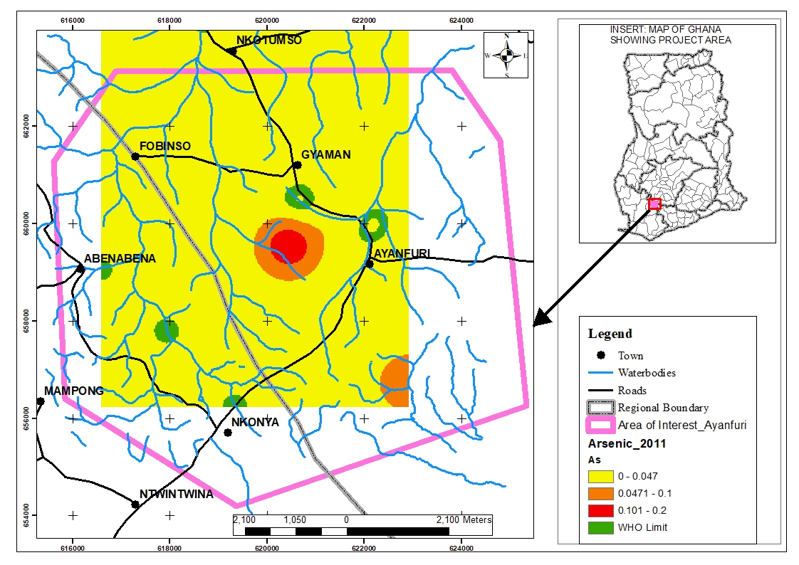

Figure : Surface Water Arsenic (As) Map July 2011

*4.1.2 Iron (Fe)*

Iron contained in the surface water between the years of interest of 2010 to 2019 from the plot appears to be prevalent in all years except for the year 2016 which recorded no Iron in the surface water exceeding the WHO limits of 0.03mg/L.

Figure : Surface Water Iron (Fe) Trend 2009-2019

The 2010 water levels show a high of 6.8 mg/L from the water in one of the old, abandoned pits of a previous large-scale operation in the Ayanfuri area which was no longer an active pit in the year 2010. All other areas within the catchment of Ayanfuri recorded levels below 3.1mg/L.

In 2011, the iron levels recorded in the catchment communities appreciated in especially Abenabena and Nkonya areas to levels between 4.6mg/L and 5.3mg/L. Ayanfuri, Gyaman, and Fobinso had levels that ranged between 0.313mg/L and 3.88mg/L.

The observed Iron levels in the Nkonya area dropped in 2012 to below 1.37mg/L, whilst the Abenabena area recorded the highest levels up to 7.6mg/L. Fobinso recorded below 5.52mg/L, whilst Gyaman and Ayanfuri recorded levels below 2.41mg/L.

In 2013, the Iron in Surface water was highest in Gyaman with the heap leach area close to Gyaman recording up to 3.25mg/L. Fobinso and Abenabena had levels between 1.16mg/L and 2.41mg/L. Ayanfuri recorded the lowest levels of Iron in the communities with a concentration of 0.306 mg/L and 0.726mg/L.

Ayanfuri and Nkonya in 2014 recorded Iron levels within the WHO Limit of less than 0.3mg/L, whilst the remaining catchment communities had levels above the WHO limit, with Gyaman recording the highest levels between 0.772mg/L and 1.4mg/L. Fobinso and Abenabena had concentrations of a maximum of 0.458mg/L and 0.615mg/L respectively.

In 2015, Ayanfuri and Nkonya had Iron concentrations falling within the WHO safe limits. The Abenabena area had marginally high concentrations falling within the range of 0.302mg/L and 0.635mg/L. Fobinso and Gyaman recorded levels falling between 0.636mg/L and 1.3mg/L.

The iron concentrations in three of the five communities, namely, Gyaman, Ayanfuri, and Nkonya were within the WHO limits. However, there was no monitoring data for Fobinso and Abenabena for the period under investigation in 2016.

Similarly, in the year 2017, the Ayanfuri area had a marginally high iron level within the range of 0.301mg/L – 0.62mg/L. Gyaman and Nkonya had levels within the WHO limits whilst Fobinso and Abenabena had no data for the year 2017 for the observation month in focus.

In 2018, the Iron in the surface water within the Ayanfuri area was within the WHO limits, Gyaman recorded the highest limit of 0.693mg/L whilst the communities of Fobinso, Abenabena, and Nkonya had levels within the 0.302mg/L – 0.497mg/L.

The surface water iron concentrations within the Ayanfuri, Fobinso, and Abenabena were within the WHO limit, whilst Gyaman recorded the highest levels recording between 0.533mg/L – 0.991mg/L. the Nkonya area recorded levels within the 0.303mg/L – 0.532mg/L.



Table : Pearson Correlation Matrix for Surface Water Iron Concentration

The correlation between the baseline and the years 2016 and 2017 were the strongest for the Surface Water Iron correlation matrix. The rest of the years recorded weaker negative and positive correlations in no particular order. This means that the years 2016 and 2017 had some of the worst occurrences of iron in surface water compared to the baseline year.

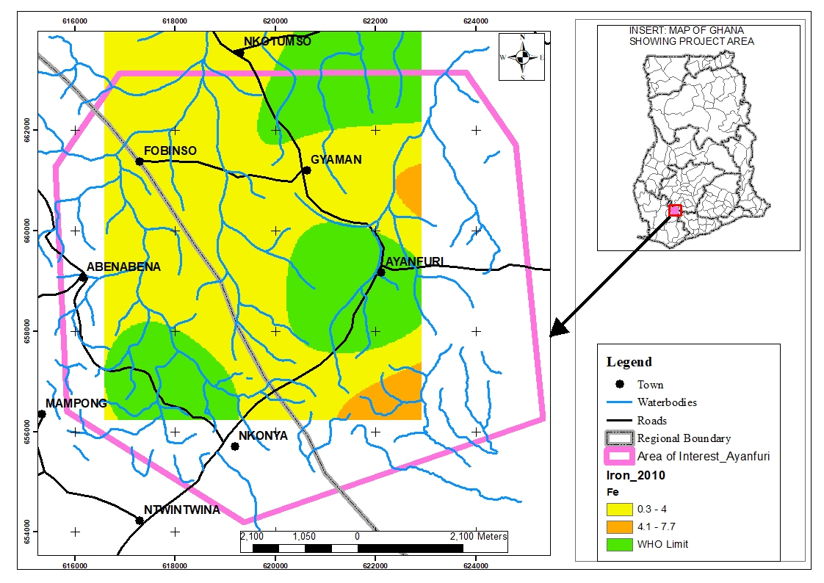

Figure : Surface Water Iron (Fe) Map 2010

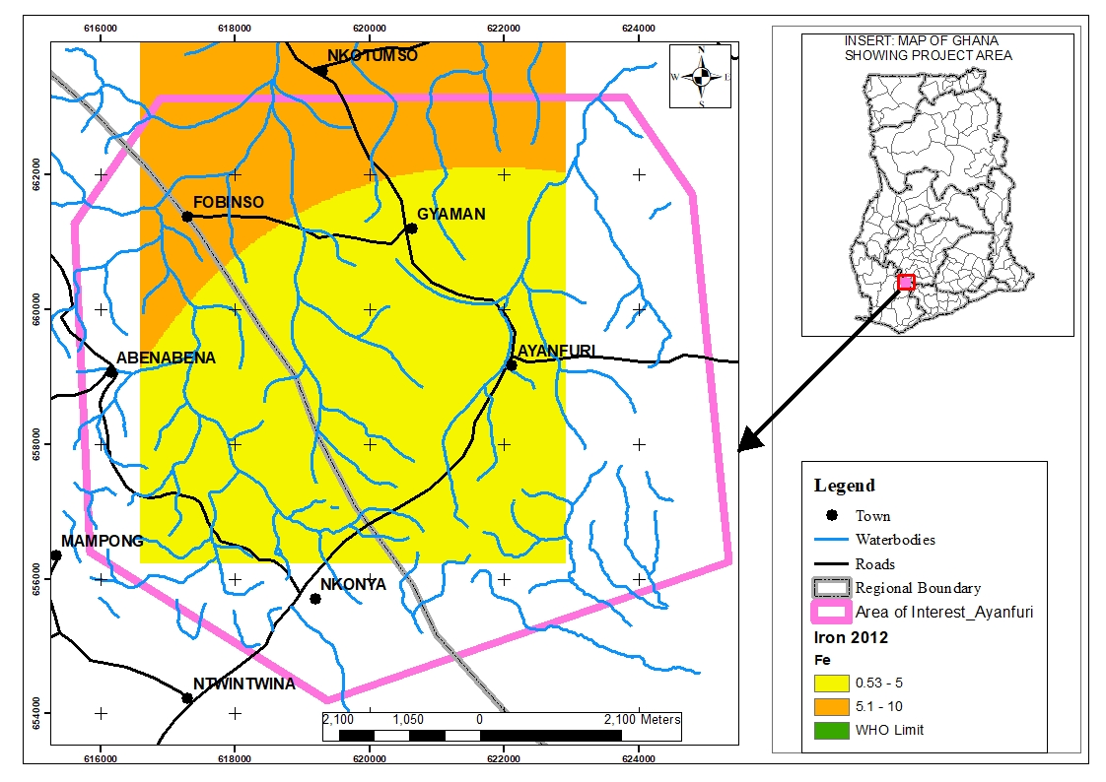

Figure : Surface Water Iron Map (2012)

*4.1.3 Mercury (Hg)*

The occurrence of Mercury in the surface water of the catchment communities around Ayanfuri was not detected between the year 2010 to 2013.

Figure : Surface Water Mercury (Hg) Trend 2009-2019

In 2014 however, the surface water around the Heap leach area recorded as high as 0.014mg/L which was the first record of Mercury within the years under investigation. This surface water which was found to be high in Mercury impacted Ayanfuri, Gyaman, and Fobinso, where the levels were within the 0.001 to 0.004mg/L range.

The surface water around the heap leach area which is between Ayanfuri and Gyaman recorded levels up to 0.0025mg/L. All the catchment communities, however, recorded levels within the WHO limit of less than 0.001mg/L.

In 2016, the heap leach area between Ayanfuri and Gyaman recorded mercury concentrations to a high of 0.00594mg/L. Gyaman, Ayanfuri, and Nkonya all recorded levels within the WHO Limit of 0.001mg/L, whilst Fobinso and Abenabena had no records for the period under investigation.

The 2017 results show an absence of Mercury in the Ayanfuri and its catchment areas, thus becoming a period with no Mercury incidence within the surface water around the Ayanfuri area.

The results for 2018 show that mercury concentrations around the heap leach area exceeded the WHO limit of 0.001mg/L. All the catchment communities, however, recorded levels within the WHO Limits.

In 2019, no areas around Ayanfuri recorded levels above the WHO limits of 0.001mg/L.

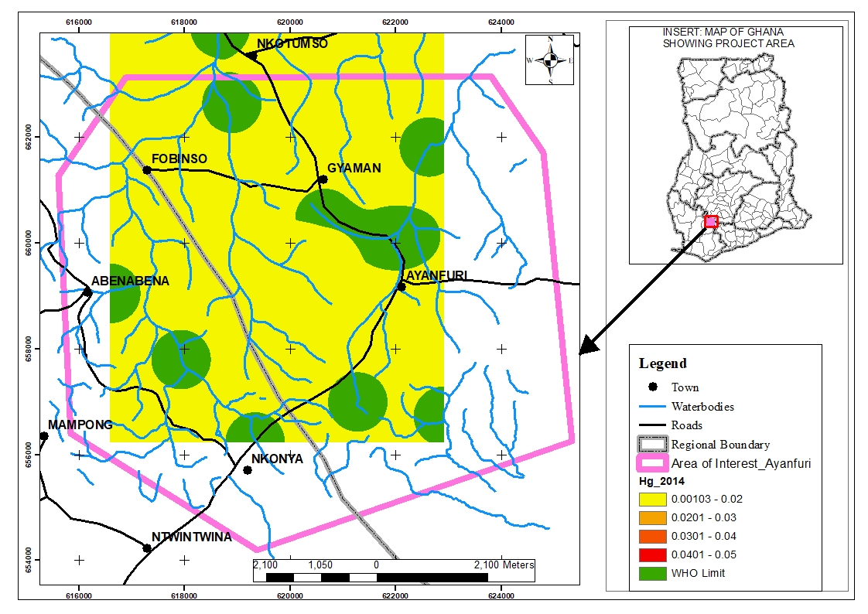

Figure : Surface Water Mercury (Hg) Map 2014



Table : Pearson Correlation Matrix for Surface Water Mercury

There is a perfect correlation for the relationship between the 2014 and 2016. Similarly, there is a perfect positive correlation of 1.000 between the year 2014 and 2018. The mercury concentrations for 2014 and 2016 are therefore perfectly correlated in the positive direction.

*4.1.4 Lead (Pb)*

The results for lead in surface water around Ayanfuri, Gyaman, Fobinso, Abenabena, and Nkonya all remained within the WHO limits of 0.001mg/L.

Figure : Surface Water Lead (Pb) Trend 2009-2019

This result demonstrates that for the ten years under investigation, there was no occurrence of Lead in the surface water resources around Ayanfuri and its environs. The baseline from 2009 however showed the presence of lead in one of the abandoned opened pits in Ayanfuri called the Chirawewa pit, which exceeded the WHO limit.

*4.1.5 Zinc (Zn)*

The zinc concentrations in the surface water in the Ayanfuri area in the years between 2010 and 2019 show all the communities have concentrations within the WHO Limit.

Figure : Surface Water Zinc (Zn) Trend 20009-2019

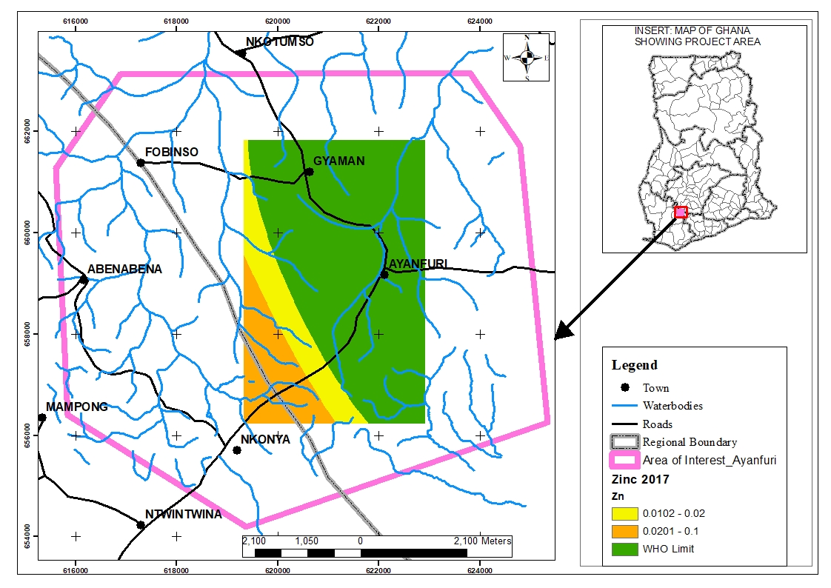

Figure : Surface Water Zinc (Zn) Map 2017



Table :Pearson Correlation Matrix of Surface Water Zinc Concentrations

There is a weak correlation in the concentration of Zinc between the baseline year of 2009 and the years 2011 and 2012. This correlation is positive for 2011 and negative for 2012. The correlation is weak in 2017 and 2018 relative to the baseline year in the negative direction. The remaining years couldn’t compute because the values of the variables were constant, that is zero.

*4.1.6 Turbidity*

The general characteristics of the Surface water in the catchment communities were also assessed to determine whether the levels of Turbidity were significant or not.

The Surface water around Ayanfuri, Gyaman, and Fobinso had high levels of Turbidity, with all the catchment communities’ surface water recording above 5 Nephelometric Turbidity Unit (NTU).

In the year 2010, none of the communities recorded Turbidity levels above 570 NTU. In the year 2011, that value increased to as high as 7600 NTU close to the Ayanfuri area, whilst all other communities recorded levels below 1100 NTU. The results for 2012 also had values as high as 31000NTU recorded near Ayanfuri, whilst all the other communities recorded levels below 4500 NTU. The 2013 results show that no surface water resources had levels above 550 NTU. In 2014, Turbidity levels remained within a maximum of 850 NTU. In 2015, the turbidity levels around Ayanfuri and its environs remained under 1200 NTU. In 2016, the levels again remained under 1100 NTU. The 2017 map shows a maximum of not more than 500NTU close to Gyaman, all other areas were below 330 NTU. The 2019 surface water turbidity was below 490 NTU in Aynafuri and its environs.

The results for turbidity over the years shows that there was significant surface disturbance for purposes mostly associated with mining, which significantly impacted the quality of the surface water resources in the communities.



Table : Pearson Correlation Matrix of Surface Water Turbidity

The correlation between the baseline year of 2009 and the years 2012,2014,2018 and 2019 was strong in the positive direction and weak for the years 2010,2013,2015,2016 and 2017.

Figure : Surface Water Turbidity Trend 2009-2019

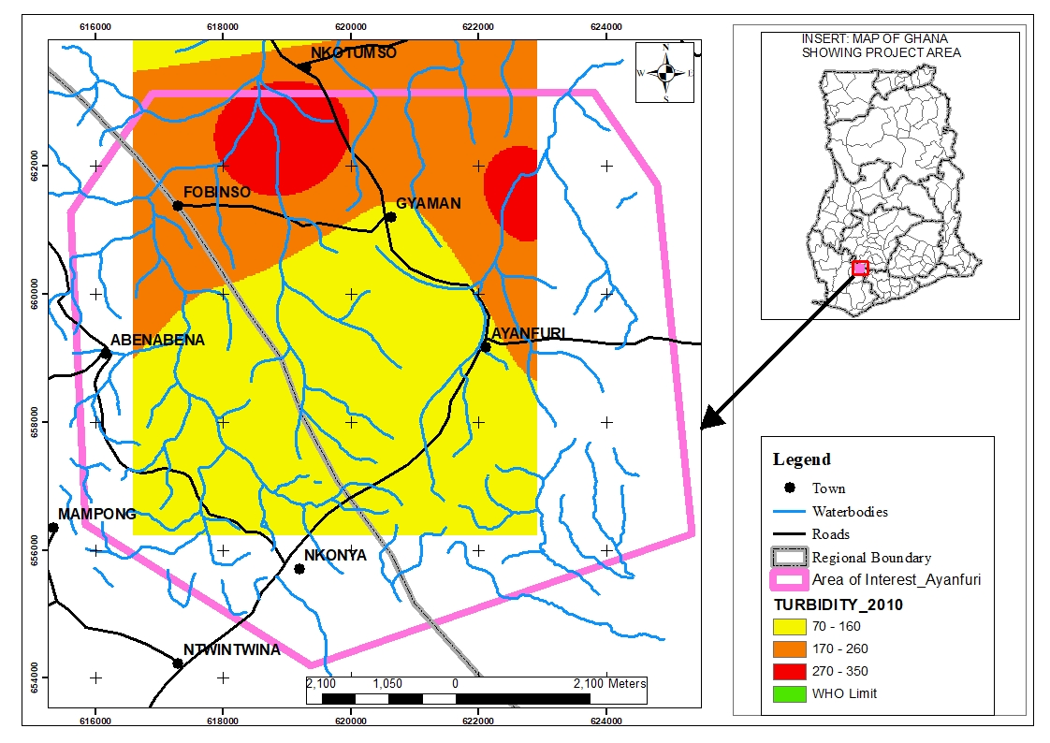

Figure : Surface Water turbidity Map 2010

*4.1.7 pH*

The surface water PH around the catchment areas of Ayanfuri and the other communities shows the water is generally not within the neutral range of 7 to 8 on the pH scale. The water generally is acidic with the Nkonya area recording the most acidic levels close to the site of the large-scale mining concession in 2010. In the year 2011, the results show that the water is generally acidic with the heap leach area near Gyaman recording the highest pH.

In 2012, the results show the water is acidic, especially at the heap leach near the Gyaman area. The remaining communities had results nearer to neutral between 5 and 7 on the pH scale. In 2013, the surface water pH generally was closer to neutral in all the communities with recorded readings between 6 and 7 on the pH scale. The 2014 pH levels within the communities again showed that most communities had a pH between 6 and 8 on the pH scale. The heap leach area showed the results for the most acidic surface water near Gyaman, with readings between 0 and 5 on the pH scale.

In 2015, all communities had water in the neutral range between 6 and 8 on the pH scale. The 2016 results show Gyaman with the highest pH levels of the communities with levels between 1 and 3 on the pH scale. The Ayanfuri and Nkonya area recorded near-neutral levels of pH between 6 and 7. The results of 2017 had levels within the very acidic range of 1 to 3 around the Gyaman area, whilst the Nkonya and Ayanfuri areas recorded between 6 and 7 on the pH scale. The year 2018 recorded pH in the communities all were near the neutral range of 5.3 and 7. The highest levels were recorded near Ayanfuri within one of the large-scale mining pits. Similarly, the 2019 records show that the communities all recorded pH between the 5.1 to 8 range, with the most acidic readings recorded in a large-scale mining pit near Ayanfuri town.

Figure : Surface Water pH Trend 2009-2019

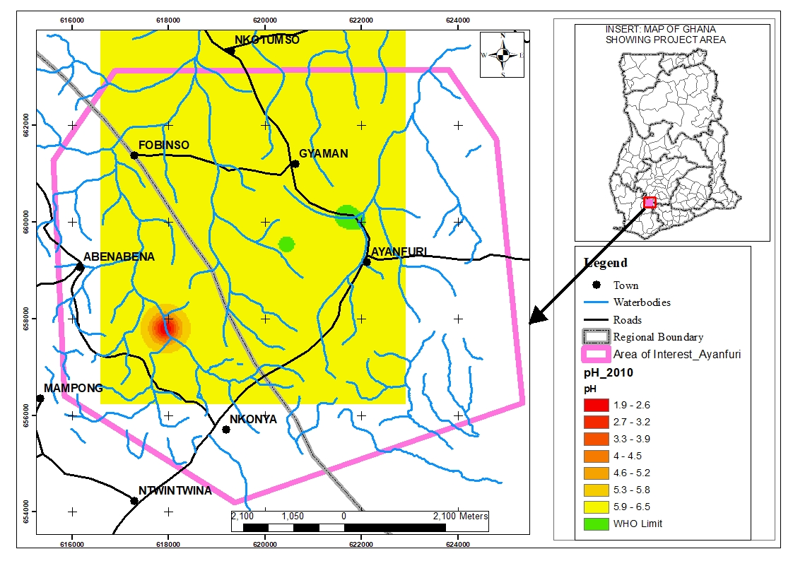

Figure : Surface Water pH Map 2010



Table : Pearson Correlation Matrix of Surface Water pH

The pH concentration correlation between the baseline year and the years 2010,2011 and 2015 is strong in the positive direction, whereas all other years had weak correlation to the baseline year.

## Trend and Spatial Distribution of Ground Water Heavy Metals

*4.2.1 Arsenic (As)*

The results for Arsenic in Community boreholes in the five communities, including Ayanfuri, Gyaman, Fobinso, Abenabena, and Nkonya show that there was no record of Arsenic concentrations exceeding the WHO limit of 0.05mg/L within the years under review, that is, 2010 to 2019.



Table : Pearson Correlation Matrix of Ground Water Arsenic

The Pearson correlation shows a weak correlation for the year 2010 relative to 2011, 2012,2018 and 2019 which was mostly in the negative direction except for the year 2012 which was weak in the positive direction.

Figure : Ground Water Arsenic (As) Trend 2009-2019

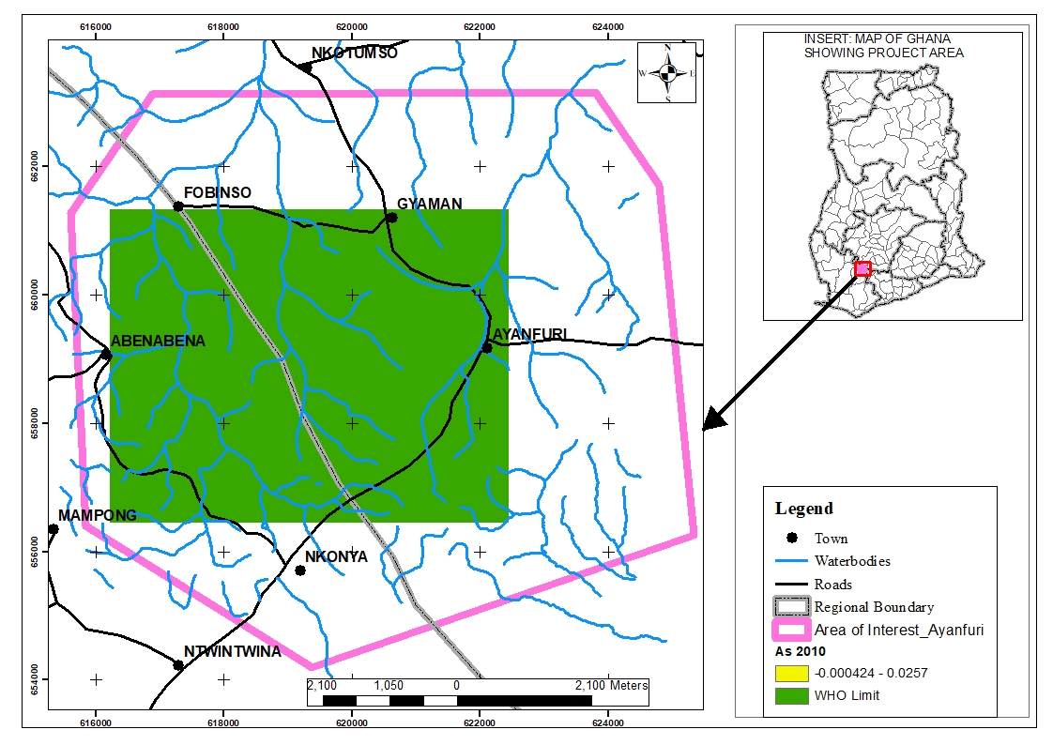

Figure : Ground Water Arsenic (As) Map 2010

*4.2.2 Iron (Fe)*

The results for Iron in the groundwater as observed from the community boreholes between 2010 and 2019 indicate that in 2010, the Iron levels in all communities remained within the WHO limit of 0.3mg/l.

Figure : Ground Water Iron (Fe) Trend 2009-2019

In 2011 however, the Abenabena and Nkonya areas had elevated levels of Iron in their community boreholes exceeding the WHO limits. The level in Abenabena was as high as 2.99 mg/l, whilst that of Nkonya was less than 0.842mg/l. The three other communities had levels within the WHO safe levels.

The results for 2012 show that Abenabena recorded slightly higher levels of Iron beyond the WHO limit, but not exceeding 0.594mg/l. All other communities had levels remaining within the WHO limits.

In 2013, Abenabena once again had levels exceeding the WHO levels but not more than 1.45mg/l. All the other four communities had levels within the WHO safe limit of 0.3 mg/l.

All the communities recorded iron levels within the WHO limit of 0.3mg/l in the years 2014, 2015, 2016,2017, and 2018.

In 2019 however, the Abenabena area once again recorded levels above the WHO limit of 0.3mg/l. the highest recorded in Abenabena for that year was 1.1mg/l. All other communities had levels within the WHO safe limits.



Table : Pearson Correlation Matrix of Ground Water Iron

The Iron concentration between the baseline year of 2009 and the years 2011 and 2013 were very strongly correlated at the 0.01 level in the positive direction. The remaining years were weakly correlated in the negative direction for 2018 and positive direction for the years 2010,2012 and 2019.

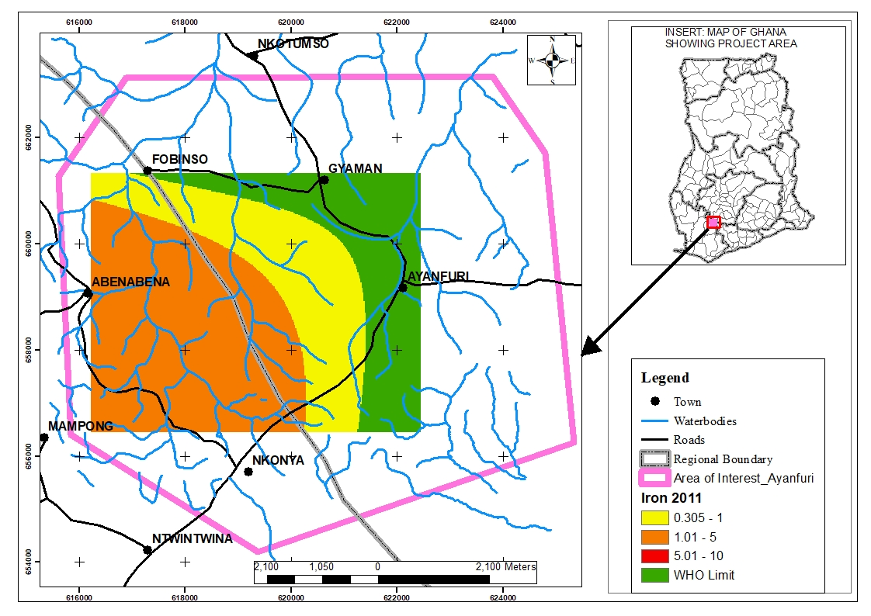

Figure : Ground Water Iron (Fe) Map 2011

*4.2.3 Mercury (Hg)*

The mercury concentrations in groundwater around the five communities including Ayanfuri showed results of Mercury within the WHO safe limits of 0.001mg/l in all years except for the year 2016.

Figure : Ground Water Mercury (Hg) Trend 2009-2019

The results for 2016 showed that the mercury levels in Fobinso exceeded the WHO limits recording a value of 0.0039mg/l. All other communities showed levels within the WHO limits.

*4.2.4 Lead (Pb)*

The results for lead in the five communities of Ayanfuri, Gyaman, Fobinso, Abenabena, and Nkonya all recorded values of lead in groundwater from community boreholes, within the WHO safe limits of 0.001mg/l for all the years under review, specifically 2010 to 2019.

Figure : Ground Water Lead (Pb) Trend 2009-2019

*4.2.5 Zinc (Zn)*

The results for groundwater Zinc for the catchment communities for the years under review, which is 2010 to 2019 showed that the limits in the catchment communities were all within the WHO limits of 5.00mg/l.

Figure : Ground Water Zinc (Zn) Trend 2009-2019



Table : Pearson Correlation Matrix of Ground Water Zinc

The correlation between the baseline Zinc Concentration is very strong with the 2019 year, all other years relative to the baseline were weak and, mostly in the negative direction. The correlation between 2009 and 2019 was significant at the 0.01 level.

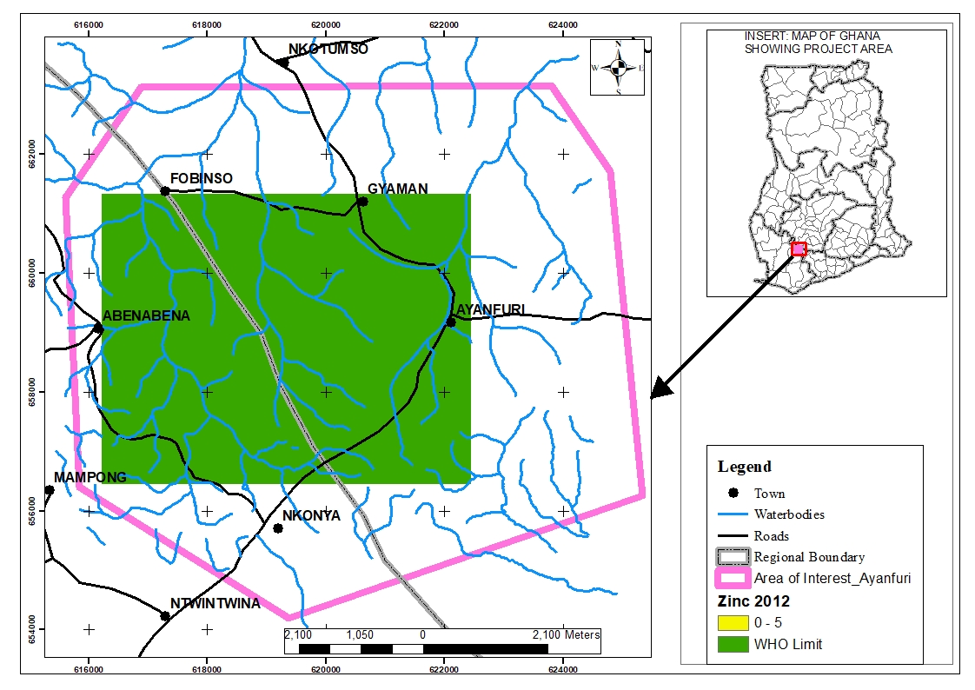

Figure : Ground Water Zinc (Zn) Map 2012

*4.2.6 Turbidity*

The groundwater in the year 2010 around the catchment communities generally is within the WHO limit of 5 NTU. In the Abenabena area,however, the recorded levels are significantly above the limits. The recorded values around Abenabena were as high as 55.80 NTU.

Figure : Ground Water Turbidity Trend 2009-2019

Similarly, in 2011, the Abenabena ara recorded a high of 41.81NTU, significantly above the limit of 5 NTU. The Nkonya area also showed some significant levels of turbidity with projected values of approximately 24.15NTU. The remaining communities had groundwater turbidity levels within the WHO limit of 5 NTU.

In 2012, the turbidity levels around Abenabena and Nkonya were high and above the WHO limits with a high of 30.42 NTU and 21.73NTU respectively. All other communities showed levels below the WHO limit of 5NTU.

In 2013, Abenabena and Gyaman showed levels of 41.83NTU and 35.86NTU respectively. All other communities had levels within the WHO limit of 5NTU. The 2014 results show that the Gyaman area recorded levels as high as 84.26NTU.



Table : Pearson Correlation Matrix of Ground Water Turbidity

The correlation for turbidity between the baseline year 2009 and the years 2011,2012,2015 and 2019 were the strongest, with 2015 and 2019 being significant at the 0.01 level, whilst 2011 and 2012 were significant at the 0.05 level. The other years were weak compared to the baseline year in both positive and negative directions.

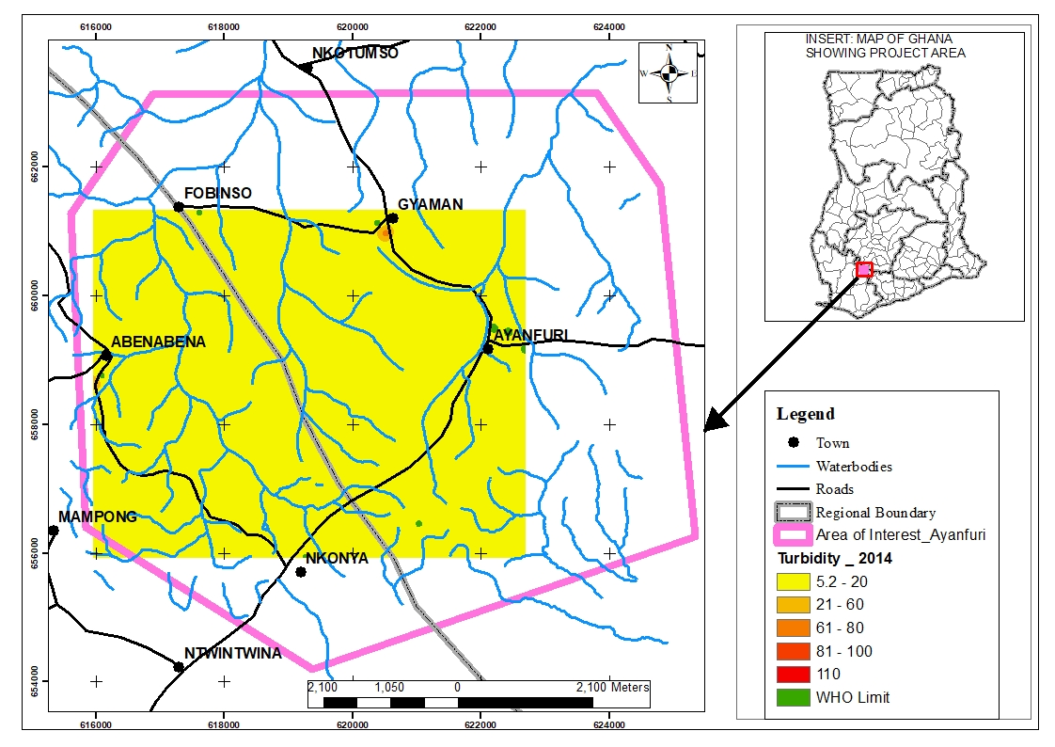

Figure : Ground Water Turbidity Map 2014

*Ground Water pH*

The groundwater in most communities over the period fell within the acidic range, which is a pH of less than 7.

In some communities however, the part of the Ayanfuri area where the mine village is located had consistent pH of 7 for most years monitored, but all other communities fell within the acidic range, though on the weaker side. The trend showed an average trend of pH between 5 and 7.



Table : Pearson Correlation Matrix of Ground Water pH

The Pearson correlation values for the year 2013 was significant at the 0.05 level, hence a strong correlation with the baseline year 2009. All other years had a weaker correlation in both the positive and negative directions.

Figure : Ground Water pH Trend 2009-2019

## Surface Disturbance Map

Figure 27 shows the surface distance maps for the years 2009, 2013, 2016 and 2019. Figure 27(a) shows that in 2009 the development around the five communities under study was concentrated in a relatively small area with vegetation being the predominant land use/land cover. Water showed surface water in the old abandoned large-scale mining pits around Ayanfuri in particular while very few settlement/bareland was seen around the catchment communities. The large patches of white and blue edges observed are as a result of clouds which showing a few outliers.

Figure 27 (b) shows that in 2013, there is a significant contrast in settlement/ bare land and vegetation. The area to the west of the Abenabena community, which was predominant in the vegetation class, now changed to the settlement/bareland class. This trend is also observed around all the communities as vegetation previously on the fringes/outskirts of the towns in the 2009 image, now changed to the settlement/bareland class. The water class also appeared to have increased around the five communities.

a.

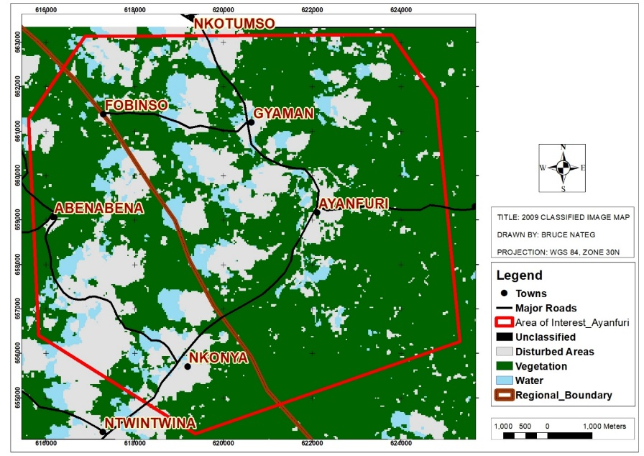

b.

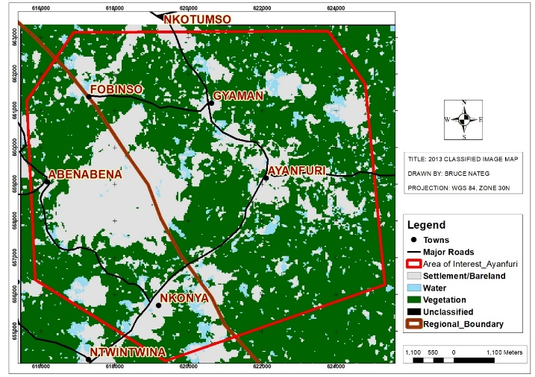

c.

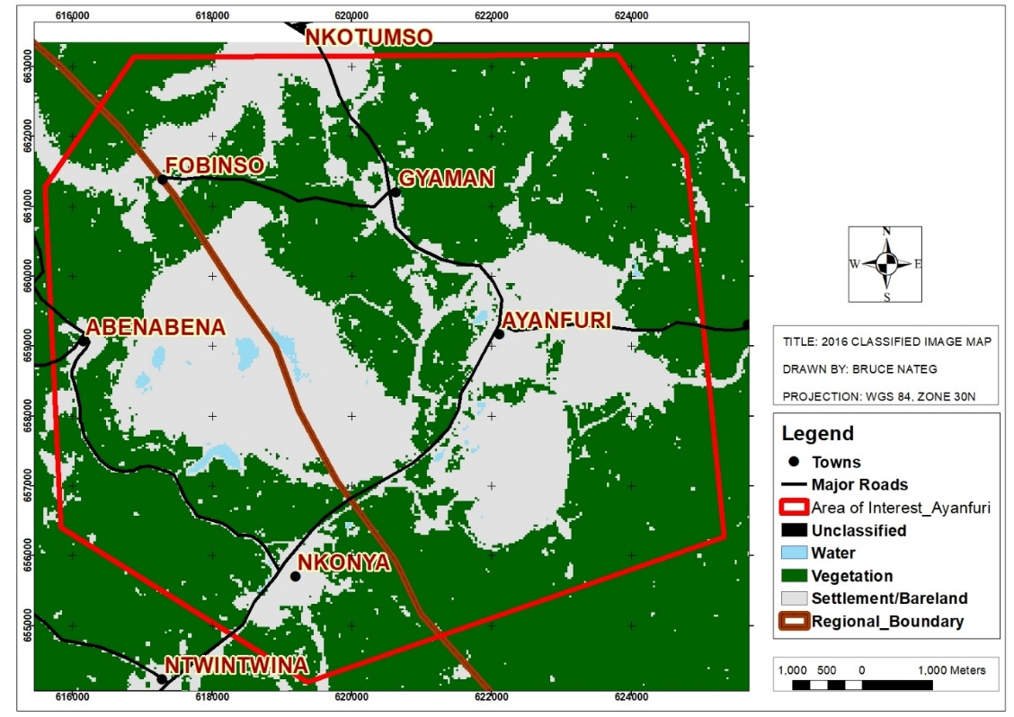

d.

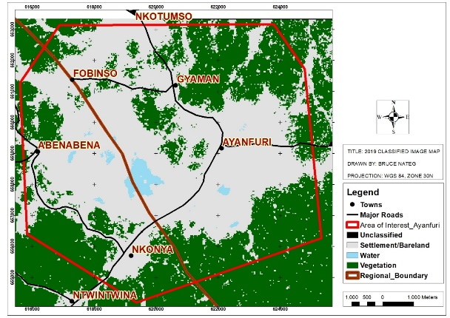

Figure : Classified images of Ayanfuri 2009,2013,2016 and 2019

In 2016 (Figure 27(c), the areas bounding the communities of Abenabena and Ayanfuri had significant changes from vegetation into the settlement/bareland. The towns themselves continue to show significant changes from the vegetation to the settlement/bareland. In Ayanfuri in particular, areas to the North, South, West, and East of the town, which were vegetation in 2013, now changed into the settlement/bareland. Ayanfuri thus appears to have had a significant change in land use between 2013 and 2016.

Figure 27 (d) shows a significant change in vegetation and settlement/bareland. Significantly, the areas to the southeast of Abenabena and the north of Nkonya appear to have changed from vegetation to the settlement/bareland. Similarly, between 2016 and 2019, the area around Ayanfuri now appears to have changed significantly from the vegetation to the settlement/bareland, especially to the west of the town, which in 2016 showed very significant vegetation now appeared to have fully transitioned into the bareland; therefore, resulting in patches of vegetation in that part of Ayanfuri. The areas surrounding Gyaman and Fobinso, which were vegetation in the year 2016 changed to settlement/bareland.

It is significant to note that the general representation of the vegetation between the years 2009 and 2019, shows a rather very significant surface disturbance either for settlements or illegal mining, with the vegetation cover significantly diminished in the interest of the settlement/bareland which clearly shows the extent to of the degradation of the vegetation .

## Discussion

## General Characteristics of Water

#### pH in Surface and Ground Water

The pH in the surface water of the five catchment communities, namely, Ayanfuri, Gyaman, Fobinso, Abenabena, and Nkonya for the period under review is general within the acidic range, with a few isolated areas showing pH within the neutral range or the WHO acceptable limit of 6.5- 8.5 (Rizwan et al. 2021), the general range for pH in the communities between 2010 and 2019 is pH of 5-7. The most acidic records were observed in the surface water around the mining pits of the large-scale mining operation and the Old Heap leach pad also the remnants of an old mining operation in the area. The pH records for 2012 and 2013 show the best pH recorded in these communities with the pH ranging between 5 and 7 for both years. All other years have areas recording highly acidic pH of between 1 and 5.

The pH of the groundwater investigated between 2010 and 2019 in the catchment communities of Ayanfuri showed that the water was within the neutral pH of 7. The only areas that showed a very slightly acidic result for groundwater were the heap leach area, the Mine Camp, and the Mining area boreholes. But these were generally between 6.5 and 7. The groundwater quality from the above within the five catchment communities was within acceptable WHO standards for pH of 6.5 to 8.5 (Rizwan et al. 2021).

#### Turbidity of Surface and Ground Water

The turbidity of water measures the level of aesthetic purity of how clear looking the water appears to the naked eye (WHO 2011). Water with turbidity value below 5NTU usually looks clear to the naked eye, however, water that has an turbidity above 5NTU looks unclear to the naked eye (WHO 2011). This is usually an indication that the water is agitated or disturbed thus resulting in the suspension of solid particles which will ordinarily be well settled in the bottom of the water.

The surface water turbidity values recorded between 2010 and 2019 were generally above the turbidity value of 5NTU in all catchment communities, with the worst values consistently being recorded downstream of the old heap leach pad in Ayanfuri. The year 2012 recorded the highest turbidity value downstream of the heap leach pad with a reading of 31000 NTU. This can be attributed to the activities of illegal artisanal miners washing the heap leach material and leaving the effluence uncontrolled to flow into the nearby stream course downstream of the heap leach pad.

The groundwater turbidity results show significant levels of turbidity in one of the communities, Abenabena for the years 2010,2011,2012 and 2013 where the highest turbidity recorded for that period was 55.8 NTU. Groundwater in Gyaman also recorded high turbidity for 2013, 2014 and 2017, with a high of 84.26 NTU in 2014. In 2018, the Nkonya area also recorded a high turbidity value of 66.1 NTU. The communities which didn’t record a high turbidity in groundwater for the period under investigation are Ayanfuri and Fonbinso. The mining infrastructure area also recorded significant groundwater turbidity in 2011, 2012, and 2016 at the camp.

## Heavy Metals in Water Resources and Trend of Occurrence

The study shows that the presence of arsenic in the Ayanfuri area is at the old heap leach pad. The study shows that the levels of arsenic in the area recorded from 2010 to 2019 have consistently been above the WHO standard of 0.01mg/l. The baseline report for the monitoring points near the heap leach pad shows that arsenic at two sample points PA19 and PA 20 in July 2009 had values of 0.038mg/l and 0.26mg/l, respectively. This was attributed to the possibility of leachate from the old heap leach or artisanal mining in the area. The 2010 monitoring data show a reading 0.44mg/l, reducing to 0.15mg/l in 2011 and remaining below 0.2mg/l until 2015 when the levels increased to 0.53mg/l, increasing in 2016 to 0.86mg/l. The Arsenic levels dropped to 0.098mg/l in 2017 and increased in 2018 and 2019 to 0.19mg/l and 0.3mg/l, respectively. The presence of arsenic poses potential health challenges to persons who encounter it. Duker (2004), investigated the relationship between the presence of arsenic in artisanal mining areas and the prevalence of Buruli Ulcers. The research clearly showed that there was a link and thus it was important to ensure Arsenic from mining activities doesn’t find its way into potable water and soils that potentially will come into contact with people and thus expose them to Buruli Ulcers and possibly other adverse health conditions.

The study shows that none of the groundwater sampling points within catchment communities of Ayanfuri, Gyaman, Fobinso, Abenabena, and Nkonya showed any presence of arsenic as compared with the results for the surface water. This indicates that the presence of arsenic in the surface water around Ayanfuri potentially is a result of surface disturbance occasioned by illegal artisanal mining activities. The persons who therefore depend on the groundwater sources within the communities potentially will be safe from the hazards associated with Arsenic in particular.

Mercury was not recorded in any of the surface water resources within the catchment communities of Ayanfuri, Gyaman, Fobinso, Abenabena, and Nkonya for the years 2010, 2011, 2012, and 2013. The first recording of mercury in surface water around Ayanfuri was in the year 2014 and it was found around the old heap leach pad, where illegal mining activities seem to have picked up tremendously around that time. Subsequently, the presence of mercury continued to be recorded in the same heap leach area in 2015,2016, and 2018. There was no record of mercury for 2017 and 2019, with both years recording below 0.001mg/l in all water samples in all five communities under investigation.

The highest recorded value for Mercury was in the year 2014 when the value was 0.014mg/l. The subsequent years where Mercury traces were found in the surface water had values not exceeding 0.0059mg/l which was recorded in 2016. The 2015 value was maximum 0.0025mg/l, whilst the 2018 value was 0.0034mg/l.

The upsurge in the illegal mining activities in the Ayanfuri area within the period likely accounted for these high and unsafe mercury levels in the results. The baseline conducted in 2009 showed that mercury was below 0.002mg/l. The records in the heap leach area of Ayanfuri are much greater than the baseline values that were recorded before the commencement of mining operations by the large-scale miner. Given that the heap leach had not yet been exploited by the large-scale miner at the time the readings of mercury were recorded and added to the fact that the large-scale miner doesn’t process for gold at the site where the heap leach pad is located and also does not use mercury in the processing plant, the logical conclusion for the presence of Mercury in the surface water recourses around Ayanfuri is likely caused by the presence of illegal miners at the heap leach prospecting for gold using very crude means such as mercury for the extraction of the precious metal. Mercury poses various health risks especially when the vapor is inhaled (Esdale and Chalker, 2018)

The groundwater readings for mercury in the community boreholes show readings below the WHO standards of 0.001mg/l for all the years under review in all communities except for the year 2016 where the reading for Fobinso showed elevated mercury levels as high as 0.0039mg/l which is significantly above the WHO limit.

The baseline from 2009 for the wells and boreholes in the catchment communities showed that the reading from Fobinso had mercury levels below 0.002mg/l. However, there is the potential that illegal mining activities which seem to have picked up in many catchment communities around the 2016 period must have contributed to the elevated levels of mercury in the groundwater around the Fobinso area. The subsequent years, however, did not record any mercury in the groundwater in the Fobinso area.

The results of surface water heavy metals between 2010 and 2019 in all catchment communities were within the WHO limit for the lead of 0.05mg/l. None of the communities recorded heavy metal in their surface water resources over the period. The groundwater results for the catchment communities between 2010 and 2019 also show an absence of Lead in the groundwater resources as all boreholes and wells in the community sampled had readings within the WHO limit of 0.05mg/l.The baseline results from SGS in 2008 show that all surface and groundwater resources within the catchment communities were less than 0.02mg/l, well within the acceptable WHO limits for Lead.

The surface water resources in the catchment communities showed that Zinc levels were within safe limits as none of the surface water samples recorded Zinc above the WHO limit of 5mg/l. In the groundwater resources, similarly, none of the communities had groundwater levels up to the WHO limit of 5mg/l. All communities had results well below this limit. Zinc is a heavy metal that is also an essential nutrient for the human body, however, it must remain within the WHO limits to be deemed acceptable for use by humans for their day-to-day activities. In the baseline report, the levels of Zinc in the surface and groundwater resources remained within the WHO limit, with no community recording any significant amount of Zinc relative to the limit of 5mg/l.

The baseline results for all sampled surface and groundwater points in 2009 by SGS showed the presence of Iron in all the sampled surface water points. The range of the Iron was between 0.22mg/l and 92.49mg/l in all the sampled points. The surface water samples analyzed between 2010 and the year 2019 show that the presence of Iron in the surface water in all catchment communities was significant and above the WHO limit. The results for the surface water resources monitored showed all areas had significant levels of Iron in the water samples exceeding the WHO limit of 0.30mg/l. the average range was between 0.3mg/l and 6.8mg/l. These were recorded between 2010 and 2015.

The years without significant levels of Iron recorded in the catchment communities are the years from 2016 to 2019. The results for groundwater samples show the presence of Iron in the results for 2011, 2013, 2018, and 2019 in Abenabena. The values ranged from >0.3mg/l to 2.99mg/l. These values are above the WHO limit of 0.3mg/l, however, compared to the values for the surface water, it certainly is substantially lower than the values recorded for the surface water points. All other communities recorded no Iron in the groundwater resources. The baseline for the groundwater sample points showed the presence of Iron in samples from Abenabena (4.6mg/l), Gyaman (0.55mg/l), and Fobinso and Ayanfuri recording values below 0.05mg/l. The results of Heavy metals in Abenabena are therefore consistent with the baseline data and thus may require further intervention to improve the Iron levels contained in the groundwater resources.

## Surface Disturbance

#### 4.4.3.1.1 2010 Landsat Image Classification

The study areas captured by a Landsat image on the 21st of December 2009, show a significant area within the study area that falls within the vegetation class after supervised classification.

Despite the presence of clouds in some parts of the image, it can be determined from the classified image that Ayanfuri town had their settlement, for instance, concentrated around the town center. Similarly, the areas that fell within the settlement/bare land class covered relatively small areas.

Some areas also fell within the water class, mostly old abandoned large-scale mining pits filled with water.

There are no patches of land showing the potential locations of illegal artisanal mining sites or large-scale mining operations within the image that was classified.

This is significant because it doesn’t show significant surface disturbance that potentially could contribute to the presence of heavy metals in the surface and groundwater resources of the catchment communities.

#### 4.4.3.1.2 2013 Landsat Image Classification

The 2013 Landsat image of the project area was acquired on the 18th of March 2013. This image in contrast to the 2009 image now shows a significant change from the vegetation class to the settlement/ bare land class. The most significant impact is recorded to the East of Abenabena town.

The large area that moved from the vegetation class to the settlement and bare land class next to Abenabena, is a result of the commencement of commercial mining operations in the area by a large-scale miner in the year 2011. The previously green vegetation made way for the mining infrastructure; pits, waste dumps, tailings storage facilities, haul roads, office setups, and other types of the infrastructure associated with mining.

The various communities which were occupying relatively very small surface areas in 2010, now significantly occupied a relatively large area. There are also small patches of land that were previously in the vegetation class also moving to the settlement/ bare land class. This shows a potential surface disturbance to make way for artisanal mining activities which appeared to have picked up in the area after 2011.

The most significant change, therefore, occurred as a result of the operations of the large-scale miner. It is worth noting that very significant areas also remained within the vegetation class.

#### 4.4.3.1.3 2016 Landsat Image Classification

The classified satellite image of 2016, which was captured on 31st December 2016 showed significant changes between the acquired image of the year 2013.

The Ayanfuri area which in 2013 had the immediate surroundings dominated by the vegetation class now transformed into the settlement/ bareland class. The area to the north, east, and south as well as significant areas to the west of the town, now fall into the settlement/bareland class.

Similarly, the Fobinso area now had areas close to waterbodies/streams near the town, which were previously in the vegetation class now appear to have changed into the settlement/bareland class. This change in land use can be attributed to the activities of illegal miners engaged in alluvial artisanal mining. The west and the southwestern part of the Fobinso area are the most affected.

The town of Nkonya also appears to have expanded beyond the immediate town center but cannot be said to be for illegal mining purposes, though potentially some areas in the peripheral areas of the town appear to have surface disturbance in favor of illegal mining activities.

The Gyaman area also expanded compared to the 2013 image. The area to the south of the Gyaman town which has the old heap leach pads of the erstwhile mining operation in the area fell within the settlement/bare land class. This was comparable to the surface disturbance observed in the 2013 image. The footprint of the settlement/bare land class for the 2016 image however reduced significantly compared to the 2013 image of the old heap leach pad area.

The drastic change in the Ayanfuri area to the North of the town was due to the commencement of mining activities by the large-scale mining company in the area in 2016.

Similarly, the southern part of the Ayanfuri town which changed from vegetation class to the settlement/bareland class was also due to the commencement of mining activities in the area in the year 2015.

The Eastern part of Ayanfuri town which also changed significantly from the vegetation class to the vegetation/bareland class was due to the construction of the Resettlement housing project in that part of the town commencing in 2015 and completing in 2016.

#### 4.4.3.1.4 2019 Landsat Image Classification

The 2019 satellite image which was acquired on 9th January 2020 but largely represents the surface disturbance and land use type up to the year 2019.

The predominant class in this image is the settlement/bareland class. The stream courses of all towns now have the class settlement/bareland compared to the majority of them falling in the vegetation class in the year 2016.

The activities along the various waterbodies signify a booming alluvial mining industry between the years 2016 and 2019. The large-scale miner’s concessions also saw a significant area changing from vegetation class to the settlement/bareland class.

## Surface Disturbance and Heavy Metals in Surface and Ground Water

*Surface Disturbance and mercury detected in Surface Water*

There is the clearest evidence yet that between the years 2016 and 2019, there were significant land use changes with the significant change being the conversion of vegetation to settlement/bareland. Land-use change had an impact on the surface water recorded within the period. The surface water mercury levels at the heap leach area increased beyond the WHO limits of 0.001mg/l, between the years 2014 and 2019. Before these recorded levels were above the standards, the mercury levels had been consistently within the WHO limits in this area. Mercury has been identified as one of the harmful heavy metals used by illegal artisanal miners in the processing of gold at various illegal artisanal small-scale mining sites. The evidence of mercury in the waterbodies has been further confirmed by the increase in artisanal mining-related surface disturbance recorded in the area for the period mercury was identified in the surface water resources of the heap leach area.

The results for Mercury in the groundwater around the catchment communities were all consistent with the WHO limit of 0.001mg/l except for the year 2016 when the mercury levels in the Fobinso area increased to 0.0039mg/l which is more than the WHO limits. It can be observed from the 2016 image that the Fobinso area had surface water bodies close to the town appearing to have their surroundings changed from the vegetation to the settlement/bareland. The evidence in the surface disturbance when compared to the likely presence of illegal miners who use Mercury in their processing for gold leads to a conclusion that the increase in the mercury levels in the groundwater of the town of Fobinso could be attributed to the use of mercury by the artisanal miners operating around the town.

*Surface Disturbance and Arsenic Detected in Surface Water*

The surface disturbance in the heap leach area increased significantly in the 2013 classified image, this trend continued in 2016 and 2019. The baseline in 2009 showed that Arsenic levels were above the WHO standards, however, this trended upward after 2010 all through to 2019. The significant increase in the levels of detected arsenic can be related to the upsurge in the surface disturbance in the area due to the operations of illegal artisanal miners who exposed the heap leach material to surface runoffs into the nearby stream courses. The arsenic problem in the heap leach area, therefore, is a problem of indiscriminate surface disturbance without any checks and controls for illegal mining.

Arsenic as recorded in Duker 2004, can be found in soil that is buried and may not impact anyone unless it is exposed and mixed with the surface, groundwater, or soil for food crops. The observed increase in the surface disturbance over the years thus has a direct correlation with the increase in the observed arsenic levels in the area. Steps, therefore, need to be taken to stop the activities that lead to the exposure of Arsenic in the heap leach area.

*Surface Disturbance and Iron in The Surface and Ground Water*

Iron was found in all the surface water in the various catchment communities during the baseline in 2009. The limits exceeded the WHO limit of 0.30 mg/l. Consistently, most communities continued to show the presence of iron in the surface and groundwater within the period 2010 to 2019. In the case of the groundwater assessed, the groundwater of the town of Abenabena had levels above the WHO limits, all others were within the limits. It is important to note that, in Ayanfuri for instance, the potable water for the Ayanfuri resettlement site has an aqualite treatment plant installed to remove iron from the groundwater before distribution. These interventions have ensured that the water levels have remained within the required WHO limits and have resulted in the majority of communities with potable water enjoying wholesome water.

The case of surface water is however different as the increase in illegal mining activities means that the various communities have levels above the WHO standards consistently over the years. The iron already seems to be naturally occurring in the area as Amponsah et al. (2015) found Iron in rainwater above the WHO limit. Therefore its presence in the surface water with the least surface disturbance aggravating the situation. For communities that may depend on the surface water in the catchment communities instead of treated borehole water, they potentially will become exposed to unsafe levels of Iron.

# CHAPTER FIVE

# CONCLUSIONS AND RECOMMENDATIONS

## 5.1 Introduction

This research has been undertaken to determine the impact of artisanal small-scale mining compared to large scale mining on the surface and groundwater resources of the catchment communities in close proximity to their operations. It establishes whether or not there is correlation between the presence of heavy metals in surface and ground water and surface disturbances in mining areas. This chapter discusses the conclusions drawn from the study and makes recommendations for future research and policy directions.

## 5.2 Conclusions

The conclusions drawn in the study have been structured into general conclusions and specific conclusions.

General Conclusions

The study had shown that combining GIS tools for spatial distribution analysis of heavy metals gives a very good spatial representation of the likely effects and extent of certain harmful heavy metals in the affected mining communities. Kriging as a tool ensured that the distribution was an unbiased interpolation and was a reliable tool in estimating the likely extent of contamination of these harmful heavy metals. The research was also able to demonstrate the correlation between surface disturbance and the presence or absence of some heavy metals, especially in the surface and groundwater resources in mining areas around Ayanfuri.

The use of remote sensing techniques in acquiring the relevant satellite images, processing them, and generating supervised classification maps for the study area to help determine the spatial extent of surface disturbance over the period under review, ensured that accurate determination of the areas most affected by both artisanal small-scale mining and the large scale mining activities and how that affects the results of groundwater and surface water in close proximity to these activities.

The presence of heavy metals in the surface water in almost all of the catchment communities and the absence of the same in the groundwater in all communities except a few means that it is advisable for communities affected by artisanal small-scale mining to resort to groundwater sources for their potable water needs other than surface water as it is potentially a safer source of water.

The general conclusions have been structured based on the deductions made on the sub-objectives of the research.

**To analyse the presence of heavy metals in the water resources around Ayanfuri and the trend of occurrence.**

The research demonstrated that some common heavy metals which have a deleterious impact on the health of persons who ingest them in large quantities were present for some of the years investigated. Key among these was Arsenic which was high around the Ayanfuri community before the large-scale mining firm commenced full operations. The study showed a downward trend from 2010 until in 2016 when it started picking up again. The Arsenic levels in 2019 were again very high, this can be seen in the Ayanfuri area where the heap leach area was taken over by illegal miners to the detriment of the water quality in that area. Iron, right from the baseline had high concentrations in the catchment communities. This trend continued with the worse impacts being observed at Ayanfuri and Abenabena. Lead also fell within the WHO limits except for one year where it exceeded the WHO limit. Mercury was also observed to be within the WHO limits and only exceeded at one sampling point. However, some heavy metals like zinc were observed to be within the WHO limits for the years under investigation.

The communities with hotbeds for illegal artisanal small-scale mining shown consistently high Arsenic and Iron concentrations in their surface water. The turbidity of the water in these communities also trended upwards for all the years reviewed.

The groundwater however showed that the trend of occurrence of Arsenic, Mercury, Lead and Zinc were within the WHO limits. The metal that trended upwards was Iron in Gyaman and Abenabena area especially. The baseline record showed the presence of iron in all communities except Ayanfuri and Gyaman. Groundwater heavy metals were mostly within WHO limits.

**To investigate the areas in the communities, with or without heavy metals in the water resources.**

The gaussian regression method in krigging was used to interpolate the distribution of the various heavy metals. The results showed that the major areas where the worst evidence of heavy metals were within the streams and downstream waterbodies of known artisanal small-scale mining. This was mostly around the heap leach area and the Fobinso area. The distribution maps for groundwater shows iron being prevalent in the communities. All other metals were not significant in the groundwater; hence no interpolation was necessary. The turbidity levels though high, were relatively insignificant compared with that of the surface water.

**To determine whether mining activities contribute to the presence of heavy metals in water resources**

The study showed that there is a relationship between surface disturbances and the presence of heavy metals in the areas investigated. The heavy metals were mostly found in the surface water resources and the area that appeared to have been disturbed by illegal mining activities. The Ayanfuri, Gyaman, Fobinso and Abenabena areas saw a significant increase in the surface disturbance between the observed years.

## 5.2 Recommendations

Following the analysis made in this study and the conclusions drawn from the study, the following recommendations have been made:

1. The research will have to be expanded to other mining areas to determine if the case of the Ayanfuri area is isolated or prevalent in those other areas with respect to heavy metals and general water quality.
2. The communities affected by illegal mining must be resourced to have alternative sources of safe potable water other than the contaminated water with heavy metals as contained in the research findings. The polluter pays policy of the Environmental Protection Agency should be applied to illegal miners who may be caught in the act to ensure they pay for the supply of potable water to communities they deprive of access to potable water for their day-to-day use. Emphasis should be placed on groundwater as a safer source of potable water than surface water.
3. Decision makers interested in having accurate data on the extent of land degradation and surface disturbance for illegal artisanal mining purposes must employ GIS tools that will help determine accurately the extent of such destruction and help with precise interventions to curtail the lasting effects of these activities. This will also help target interventions to curtail the effects of mining in the areas where it is most needed.
4. There should be community sensitization programs with the public health departments in the various districts, educating persons in the various communities exposed to illegal mining to know the lasting effects of the contamination of the water bodies and the need to ensure they protect their lands against the invading illegal mining menace and depend on only safe potable water to save their lives and that of the younger generations.

# REFERENCES

1. Abaidoo C.A., Osei E.M., Arko-Adjei A., Prah B.E.K., Monitoring the Extent of Reclamation of Small-Scale Mining Areas Using Artificial Neural Networks. Heliyon 5(2019) e01445.doi: 10.1016/j.heliyon.2019.e01445.
2. Abbasi, S.A.; Abassi, N.: Soni, R., (1998). Heavy metal in the environment, 1st.Ed.., Mital publication, New Delhi, India.
3. Adriano D.C., Trace Elements in the Terrestrial Environment. Springer – Verlag, New York, 18-20 (1986).
4. Agyarko K., Dartey E., Kufour R.A.,Sarkodie P.A., Assessment of Trace Elements Levels in Sediement and Water in some Artisanal and Small Mining (ASM)Localities in Ghana. Curr. World Environ., Vol.9 (1),07-16(2014).
5. Agyeman I (2010). Population dynamics and health hazards of small-scale mining activity in the Bolgatanga and Talensi-Nabdam Districts of the upper east region of Ghana.Indian J.Sci.Technol.,3(10), ISSN:0974-6846.
6. Akabzaa T, Darimani A (2001). The Impact of mining sector investment in Ghana: A case study of the Tarkwa mining region. A draft report, Structural Adjustment Participatory Review International Network (SAPRIN), Accra, Ghana.
7. Amegbey, N.A.; Eshun P.A.; Mercury use and occupational exposure in the Ghanaian small-scale gold industry. Ghana mining j.2003,7,54-61.
8. Amman, A.A.; Michalke, B.; Schramel, P., (2002). Speciation of heavy metals in environmental water by ion chromatography coupled to ICP-MS. Anal.Biochem., 372, 448-452.
9. Amponsah, N. & Bakobie, Noel & Cobbina, Samuel & Duwiejuah, Abudu. (2015). Assessment of Rainwater Quality in Ayanfuri, Ghana. American Chemical Science Journal. 6. 172-182. 10.9734/ACSJ/2015/15881.
10. Armah F.A.; Obiri, S.; Yawson, D.O.; Onumah, E.E.;Yengoh,G.T.; Afrifa E.K.A.; Odoi, J.O. (2010) Anthropogenic sources and environmentally relevant concentrations of heavy metals in surface water of a mining district in Ghana: a multivariate statistical approach, journal of Environmental Science and Health, Part A: Toxic/Hazardous Substances and Environmental Engineering, 45:13, 1804-1813, DOI: 10.1080/109334529.2010.513296
11. Asare A., Asamoah B.D., Sanful P.O. (2019). Assessment of Heavy Metal Contaminants using pollution indices in Ankobra River at Prestea Huni-Valley District, Ghana. Journal of Geoscience and Environment Protection,2019,7,25-35.
12. Atua E.M.; Annan S.T.; Nyame F. (2014) Water Quality analysis of rivers used as drinking sources in artisanal gold mining communities of the Akyem-Abuakwa area: A multivariate statistical Approach. Ghana Journal of Geography Vol. 6,2014, pages 24-41
13. Awumbila M., Tsikata D., (2004). Migration Dynamics and small-scale gold mining in northeastern Ghana: Implications for Sustainable rural livelihood. ISSER, Univ. of Ghana, Accra, Ghana.
14. Basu, N.; Clarke, E.; Green, A.; Long, R.; Calys-Tagoe, B; Chan, L.H.M.; Dzodzomenyo, M; Fobil, J.N.; Neitzel, R.L.; Obiri, S.; et al. integrated assessment of artisanal and small scale gold mining in Ghana-Part 1:Human Health Review.int.j.Environ. Res. Public Health 2015, 12,5143-5176.
15. Bempah, K.B., Ewusi, A., Obiri-Yeboah, S., Asabere, S.B., Mensah, F., Boateng, J., Voigt, H.J., (2013). Distribution of Arsenic and Heavy Metals from Mine Tailings Dams at Obuasi Municipality of Ghana. American Journal of Engineering Research (AJER) e-ISSN:2320-0847 p-ISSN 2320-0936 volume – 02, Issue – 05, pp-61-70.
16. Boampomsem, L.K.; Adam, J.I.; Dampare, S.B.;Owusu-Ansah, E.; Addae, G.; Heavy metals level in streams of Tarkwa gold mining area of Ghana. J.Chem.Pharm. Res., 2010, 2(3):504-527.
17. Duker A.A., Ndur S., Osei E.M.Jnr., Acheampong I.A., Apedo G.A. (2018), Drinking Arsenic Water May Contribute to Mycobacterium Ulcerans Infection. Arch Epidemiol: AEPD-122.DOI:10.29011/2577-2252.100022
18. CHRAJ (2008). Human rights violation in mining operations in Ghana (CHRAJ) (pp23-98). Accra, Ghana.
19. CHRAJ (2006). State of Human Rights in Mining Communities, CHRAJ, Stakeholders forum (2006-2008) (pp154-161).Accra, Ghana.
20. COCOBOD. Available online; www.cocobod.gh/weakly_purchase.php (accessed on January 2020).
21. Dass, R.K.; Bhowmick, S.; Ghosh, S.P.; Dutta, S., (1997). Coliform and fecal coliform bacterial load in a stretch of Hooghly, in K.K Vass and M. Sinha, (Eds.) Proceeding of the National seminar on changing perspectives of inland fisheries Society of India, Barrackpore.
22. Donkor, A.K. & Bonzongo, Jean-Claude & Nartey, Vincent & Adotey, Destwin. (2006). Mercury in different environmental compartments of the Pra River Basin, Ghana. The Science of the total environment. 368. 164-76. 10.1016/j.scitotenv.2005.09.046.
23. Duker A.A., Ndur S., Osei E.M.Jnr., Acheampong I.A., Apedo G.A. (2018), Drinking Arsenic Water May Contribute to Mycobacterium Ulcerans Infection. Arch Epidemiol: AEPD-122.DOI:10.29011/2577-2252.100022
24. Duker A.A.; Carranza J.M.; Hale M., (2004), Spatial dependency if Buruli Ulcer prevalence on arsenic enriched domains in Amansie West District, Ghana: implications for arsenic mediation in Mycobacterium ulcerans infection. International Journal of Health Geographics 2004,3:19 doi:10.1186/1476-072x-3-19
25. Environment Impact Statement, Central Ashanti Gold Project, March 2010.
26. Esdaile, L.J. and Chalker, J.M., 2018. The mercury problem in artisanal and small‐scale gold mining. *Chemistry–A European Journal*, *24*(27), pp.6905-6916.
27. Ghosh, S.; Vass, K.K., (1997). Role of sewage treatment plant in Environmental mitigation. K.K Vass and M. Sinha (Eds.), Proceedings of the national seminar on changing perspectives of the national seminar on changing perspectives of inland fisheries, Inland Fisheries Society of India, Barrakpore, 36-40.
28. Ghana Statistical Service, 2010 Population and Housing Census, National Analytical Report, October 2014.
29. Gyau-Boakye P; Kankam-Yeboah K; Darko P.K.; Dapaah-Siakwan S. (2008). Groundwater as a vital Resource for Rural Development: An Example from Ghana. In: Adelana and MacDonald, (Eds.), Applied Groundwater Studies in Africa. CRC Press, New York, USA, pp:149-190.
30. Haile, M., Hussein, O., & Haile, Y. (2017). Adverse Health Effects of Mercury Use on Illegal Gold Miners: A Study in Garasi, Eritrea. Advances in Biochemistry, 5(2), 16.
31. Hilson G (2001). A contextual review of the Ghanaian small-scale mining industry, Washington DC: International Institute for Environment and Development & and World Bank Council for Sustainable Development, World Bank.
32. International Labour organization; Child Labour in Gold Mining. Available online; [www.ilo.org/global/about-the-ilo/media-center/press-releases/wcms_007929/lang--en/index.htm](http://www.ilo.org/global/about-the-ilo/media-center/press-releases/wcms_007929/lang--en/index.htm) ( accessed on 10 January, 2015)
33. International Finance Corporation (IFC), Artisanal and Small-Scale Mining: Challenges and Opportunities, http:// Commdev.org. (20120. Retrieved in December 2013).
34. International Finance Corporation (IFC), Sustainable and Responsible Mining in Africa, A Getting Started Guide. January 2014.
35. Jain, V.K., (1978). Studies on the effect of cadmium on the growth pattern of phaseolus aurius varieties, Absi, I. Bot. Conf. JIBS.,57-84.
36. Jang, M., Harvey, J.S., Choi, S.I., & Park, J.K. (2005). Remediation of arsenic-contaminated soils and washing effluents chemosphere, 60, 344-354.
37. Johnson, F.M., (1998). The genetic effects of environmental lead., Mutat. Res., 410, 123-140.
38. Kar D., Sur P., Mandel S.K., Saha T., Kole R.K., Assessment of heavy metal pollution in surface water, Int. J. Environ. Sci. Tech. 5: 119-124 (2008).
39. Khan, R., Israili, S.H., Ahmad, H. *et al.* (2005). Heavy Metal Pollution Assessment in Surface Water Bodies and its Suitability for Irrigation around the Neyevli Lignite Mines and Associated Industrial Complex, Tamil Nadu, India. *Mine Water Environ* **24**, 155–161 (2005). https://doi.org/10.1007/s10230-005-0087-x
40. Kumah A (2006). Sustainability and gold mining in the developing world. J Cleaner Prod.14 (3-4):315-323.
41. Kwaansa-Ansah, E.E., Amenorfe, L.P., Armah, E.K. *et al.* (2017). Human health risk assessment of cyanide levels in water and tuber crops from Kenyasi, a mining community in the Brong Ahafo Region of Ghana. *FoodContamination* **4**, 16 (2017). https://doi.org/10.1186/s40550-017-0061-y
42. Kyeremateng-Amoah, E.; Clarke, E.E. Injuries among Artisanal and Small-Scale Gold miners in Ghana, int.j. Environ.Res.Public Health 2015, 12,10886-10896;doi:10.3390/ijerph 120910886
43. Lantzy, R.J.; Mackenzie, F.T., (1979). Atmospheric trace metals: global cycles and assessment of man’s impact, Geochim. Cosmochim. Acta., 43,511-525.
44. Lee, M., Paik, I., Kang, H., Lee, S. (2007). Remediation of heavy metal contaminated groundwater originated from abandoned mine using lime and calcium carbonate, Journal of Hazard Materials, 144,208-214.
45. Marschner, H. (1995) Functions of Mineral Nutrients: Micronutrients. In: Mineral Nutrition of Higher Plants, 2nd Edition, Academic Press, London, 313-404.
46. Mining Journal (2010). Ghana, a supplementary to the mining Journal. Special publication Ghana. Aspermont UK, (March).
47. Nriagu, J.O, (1979). Global inventory of natural and anthropogenic emissions of trace metals to the atmosphere, Nature, 279, 409-411
48. Nair I.V., Singh K., Arumugam M., Gangadhar K., Clarson D., Trace metal quality of Meenachil River at Kottayam, Kerala ( India) by Principal Component Analysis, World Appl. Sci. J. 9: 1100-1107 (2010).
49. Nartey V.K., Klake R.K., Hayford E.K., Doamekpor L.K, Appoh R.K., Assessment of Mercury Pollution in Rivers and Streams around Artisanal Gold Mining Areas of the Birim North District of Ghana, Journal of Environmental Protection. 2: 1227-1239 (2011).
50. Obiri S., Dodoo D.K., Essuamang D.K., Okai-Sam F., Adjorlolo G (2006). Cancer and non-cancer human health risk from eating cassava grown in some mining communities in Ghana. Environ. Monit. Assess, 3(2):31-51.
51. Ojo J., Oketayo O., Trace Elements in the food chain – Environmental impact of small scale/artisanal gold mining in Ile-Ife 2: heavy metal concentration of water, Proceedings of an international symposium on trace elements in the food chain, Budapest, Hungary, 25-27 May,201-205(2006).
52. Olayinka, K.O. (2004). Studies on Industrial Pollution in Nigeria: The effect of Textile Effluents on quality of groundwater in some parts of Lagos. Nigerian Journal of Health and Biomedical Sciences.3,27-30. <https://doi.org/10.4314/njhbs.v3i1.11507>
53. Ontoyin, J.; Agyemang, I., (2014) Environmental and rural livelihoods implications of small-scale gold mining in Talensi-Nabdan Districts in Northern Ghana.J. Geogr. Reg. Plan. Vol.7(8), pp.150-159.
54. Rizwan, K. & Venugopal, Thirukumaran & Suresh, M.. (2021). Assessment and source identification of heavy metal contamination of groundwater using geospatial technology in Gadilam River basin, Tamil Nadu, India. Applied Water Science. 11. 10.1007/s13201-021-01436-y.
55. Ross, S.M., (1994). Toxic metals in soil-plant systems, Wiley, Chichester, U.K.
56. Tsuji, L.J.S.; Karagatzides, J.D., (2001). Chronic lead exposure, body condition and testis mass in wild Mallard Ducks, B. Environ. Contam. Tox., 67, 489-495.
57. Weiner, E.R. Application of environmental chemistry: A Practical Guide for Environmental Professionals. CRC Press: Buca Raton Florida, USA;2000.
58. World Health Organisation (2011). Guidelines for Drinking-water quality. Fourth Edition. Page 228-229